

**Sadat Academy**

**Faculty of Computers and Information Systems**

**Department of Software Engineering**

**Guide Go**

***Submitted By***

* Ahmed Mohamed Einshouka
* Abdelrahman Salah Darwish
* Ebrahim Mohamed Abdelmagied

***Supervised By***

Dr. Youssef Senousy

2024

**DECLARATION**

we hereby certify that this material is entirely my own work, that I have exercised reasonable care to ensure that the work is original and does not to the best of my knowledge breach any law of copyright and has not been taken from the work of others save and to the extent that such work has been cited and acknowledged within the text of my work.

**Group members:**

**Name Signature**

Student name Ahmed Mohamed Einshouka

Student name Abdelrahman Salah Darwish

Student name Ebrahim Mohamed Abdelmagied

**Abstract**

This project aims to provide comprehensive travel assistance for low-budget travelers who face challenges in finding suitable companions, accommodation, transportation, and equipment for their trips. The project consists of four components: tour guides, house rentals, car rentals, and camera rentals. The tour guides component connects travelers with local experts who have established relations with the people and places in their destinations. The local experts can offer personalized and authentic experiences and communicate easily with the travelers. The house rentals component offers travelers access to affordable and comfortable accommodation that meets their preferences and requirements. The car rentals component allows travelers to rent cars at competitive rates and explore their destinations at their own pace. The camera rentals component enables travelers to rent cameras and capture memorable moments during their trips without investing in expensive equipment. The project also leverages the sharing economy to facilitate peer-to-peer transactions and support local communities. The project aims to enhance the travel experience of low-budget travelers by improving their satisfaction and enjoyment of their trips. The project also intends to make travel experiences more accessible and appealing for all.

**TABLE OF CONTENTS**

|  |  |
| --- | --- |
| **Content** | **Page** |
| **Title Page** | **1** |
| **Declaration** | **2** |
| **Abstract** | **3** |
| **Table of Contents** | **4** |
| **List of Figures** | **5** |
| **List of Tables** | **6** |
| **Chapter 1: Introduction** | **11** |
| **Chapter 2: Literature review** | **29** |
| **Chapter 3: System Analysis** | **34** |
| **Chapter 4: System Design** | **72** |
| **Chapter 5: System Implementation** | **113** |
| **Chapter 6: Testing Methodology** | **121** |
| **Chapter 7: Conclusion and Future Work** | **129** |
| **References** | **134** |

**LIST of FIGURES**

**Figure 1.3** **Context Diagram ……………………………………40**

**Figure 2.3 Use-Case Diagram…………………………………...42**

**Figure 3.3 Use-Case Diagram…………………………………...45**

**Figure 4.3 Use-Case Diagram…………………………………...48**

**Figure 5.3 Activity Diagram………………………………….....51**

**Figure 6.3 Activity Diagram………………………………….....54**

**Figure 7.3 Activity Diagram………………………………….....57**

**Figure 8.3 Sequence Diagram…………………………………...60**

**Figure 9.3 Sequence Diagram…………………………………...63**

**Figure 10.3 Sequence Diagram………………………………….66**

**Figure 11.3 Architecture Diagram………………………………69**

**Figure 12.3 Class Diagram………………………………………73**

**Figure 13.3 Class Diagram………………………………………76**

**Figure 14.3 Class Diagram………………………………………79**

**Figure 1.4 ERD…………………………………………………...82**

**Figure 2.4 Flow diagram…………………………………………89**

**Figure 3.4 UI splash………………………………………………93**

**Figure 4.4 UI Sign-up…………………………………………….95**

**Figure 5.4 UI log-in…………………………………………….96**

**Figure 6.4 UI overview…………………………………………98**

**Figure 7.4 UI discover…………………………………………100**

**Figure 8.4 UI** **design……………………………………………101**

**Figure 9.4 UI design ……………………………………………102**

**Figure 10.4** **UI design …………………………………………..103**

**Figure 11.4 UI design …………………………………..............104**

**Figure 12.4 UI design …………………………………..............105**

**Figure 13.4 UI design …………………………………..............106**

**Figure 14.4 UI design …………………………………………..107**

**Figure 15.4 UI design …………………………………………..108**

**Figure 16.4 UI design …………………………………………..109**

**Figure 17.4 UI design …………………………………………..110**

**Figure 18.4 UI design …………………………………………..118**

**Figure 19.4 UI design …………………………………………..119**

**Figure 20.4 UI design …………………………………………..120**

**LIST OF TABLES**

**Table 1.6 ………………………………………123**

**Table 2.6 ………………………………………124**

**Table 3.6 ………………………………………125**

**Table 4.6 ………………………………………125**

**Table 5.6 ………………………………………126**

**Table 6.6 ………………………………………126**

**Table 7.6 ………………………………………127**

**Table 8.6 ………………………………………127**

**Table 9.6 ………………………………………128**

**Table of Contents**

Table of contents………………………………..............3

Chapter One: introduction……………………...............9

* 1. introduction……………………………… ...........10

1.2 Project Idea and Scope.............................................13

1.3 Problem Definition ………………………………..15

1.4 System Objectives ………………………………...19

1.5 System Features……………………………………20

1.6 Related Works (analysis of previous works)……… 23

1.7 System Requirements………………………………23

1.8 System Users……………………………………….26

1.9 Methodology……………………………………….27

1.10 Structure of the report…………………………….28

Chapter Two: Literature Review ....................................29

2.1 Background………………………………………...30

2.2Review of relevant literature, theories, and methodologies…………………………………………32

2.3 Analysis of existing solutions or similar projects…32

2.4 Identification of gaps or opportunities for improvement…………………………………………..33

Chapter Three: System Analysis……………………..34

3.1 User Requirements……………………………….35

3.1.1Functional requirements………………………..35

3.1.2Non-functional requirements …………………..37

3.2 System Requirement...............................................38

3.3 System Diagrams....................................................40

3.3.1Context Diagram………………………………..40

3.3.2Use case diagram ……………………………….42

3.3.3Activity diagram………………………………...51

3.3.4Sequence diagram……………………………….60

3.3.5 Component/Architecture diagram……………….69

Chapter Four: System Design…………………………72

4.1 Class Diagram……………………………………..73

4.2 Database structure ERD…………………………. 82

4.3 Structure Chart…………………………………… 89

4.4 User Interface Design……………………………. 93

Chapter Five: implementation……………..................113

5.1 Overview about programming language used........114

5.2 Overview about used tools.....................................114

5.3 Screenshot of the system............................. ……..117

Chapter six: Testing Methodology……………………121

6.1 Testing methodology ……………………………..122

6.2 Login validation…………………………………..122

6.3 Sign up validation………………………………...123

6.4 Main functions validation………………………...124

Chapter Seven: Conclusion and Future Work………...129

7.1 Conclusion………………………………………..130

7.2 Future Work………………………………………131

Reference......................................................................134

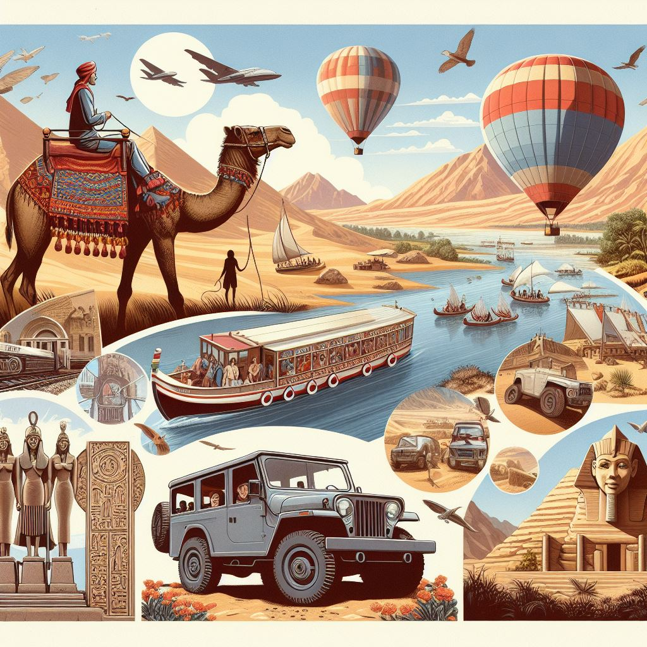

**Chapter One**

Project-Framework

**Introduction**

Traveling on a low budget can be challenging for individuals who want to enjoy their trips without compromising on quality or convenience. Many travelers face difficulties in finding suitable companions, accommodation, transportation, and equipment for their trips. This project aims to address this problem by providing comprehensive travel assistance that includes tour guides, house rentals, car rentals, and camera rentals in various locations. The project’s objective is to enhance the travel experience of low-budget travelers by offering them reliable and affordable solutions for their needs.

The project consists of four main components: tour guides, house rentals, car rentals, and camera rentals. The tour guides component connects users with local experts who can guide them through their chosen destinations and share valuable insights into the culture and attractions of the places. The house rentals component offers users access to affordable accommodation that matches their preferences and requirements. The car rentals component allows users to rent cars at competitive rates and explore their destinations at their own pace. The camera rentals component enables users to rent cameras and capture memorable moments during their trips without investing in expensive equipment.

The project’s expected outcomes are to empower low-budget travelers by providing them with comprehensive travel assistance that improves their satisfaction and enjoyment of their trips. By offering these services at a low cost, the project aims to make travel experiences more accessible and appealing for all.

**Project Idea** **& Scope**

**Idea**: Guide Go is a comprehensive travel assistance application designed to cater to low-budget travelers. The application integrates various services, including tour guides, house rentals, car rentals, and camera rentals, to provide a one-stop solution for travelers.

**Motivation:** Traveling is one of the most rewarding and enriching experiences in life. It allows us to discover new places, cultures, and people and to broaden our horizons and perspectives. However, traveling can also be expensive and stressful, especially for those who have limited budgets and resources. Many travelers face challenges such as finding suitable accommodation, transportation, guidance, and equipment for their trips. These challenges can affect their enjoyment and satisfaction of their travel experiences and discourage them from pursuing their passion for exploration.

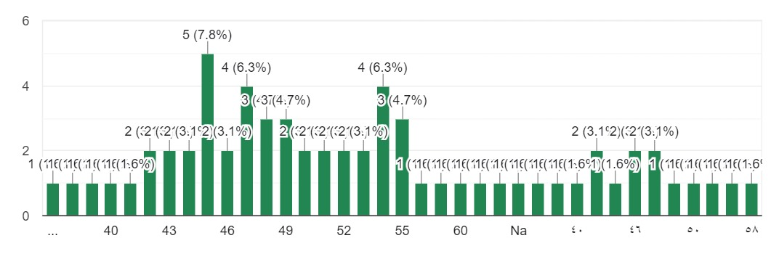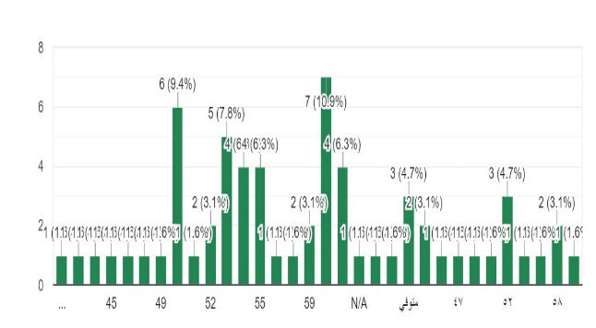One of the main problems we encountered, and which led us to work on this idea, after conducting a survey, is the graph[1][2] that illustrates the difficulties of traveling for young people or anyone who may be traveling or enjoys moving from one place to another to explore and spend enjoyable time. When they go out or travel, they usually go out with their families, which is the first part of the problem that the second graph illustrates. It's about the ages of parents, as there is often a significant age gap between them and their children. When they travel together, it can lead to problems because parents may not like to go out or travel

a lot with their children. In many cases, they also refuse to let their children go out alone, especially if they are daughters, and

this hinders the enjoyment of the trip.

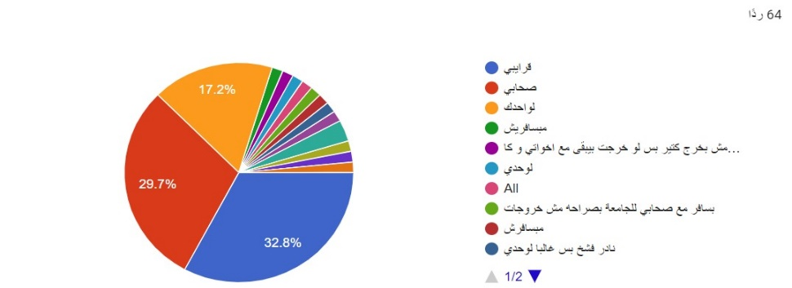Another part of the problem is, unfortunately, the lack of alignment of schedules among friends due to their commitments and schedules, which do not always coincide. This is not available to most of the group of friends, even if it consists of only three or four individuals.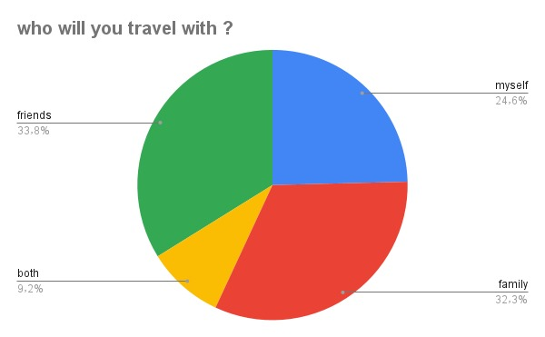Now, we come to the most important part of the graph[3], which is the percentage of people who travel alone. This can be boring because when you're alone in a foreign place, you need someone with you, even if you don't know them or they are strangers to you. This person can provide you with several benefits, such as transportation options, places to visit, recommendations for places to stay, or even offering to rent you a

room in their home or provide you with their car if needed. This person can even provide you with a camera for photography.

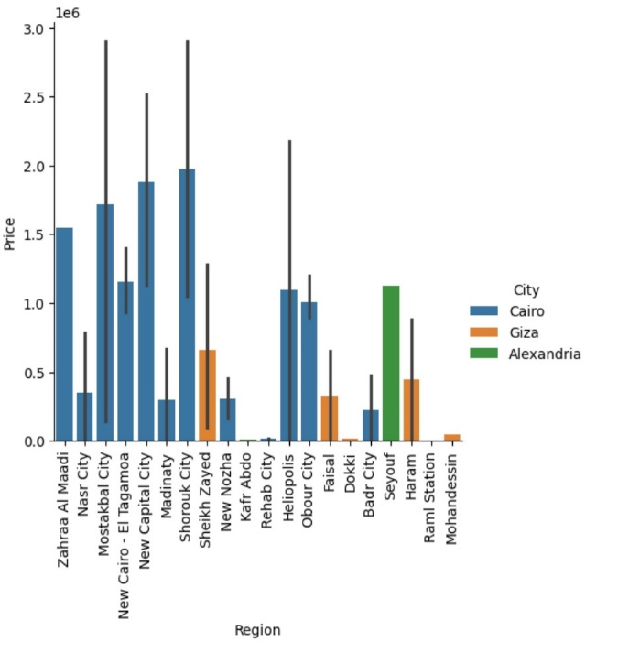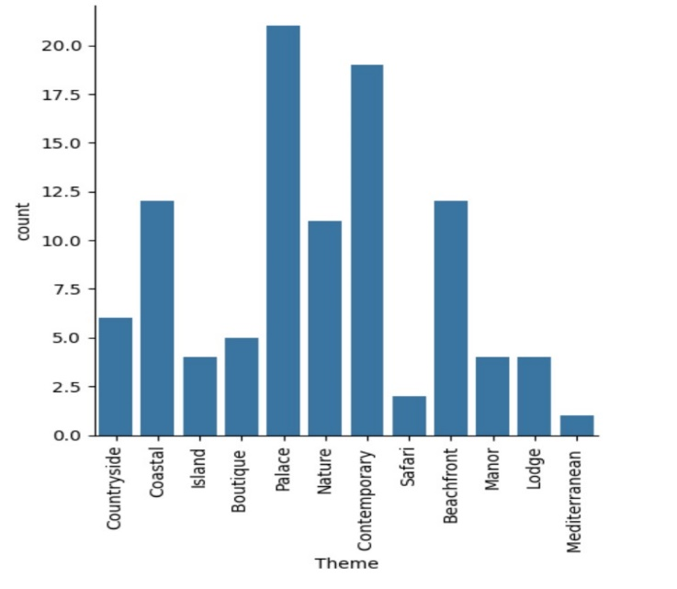This project aims to solve these challenges by providing low-budget travelers with comprehensive travel assistance that includes tour guides, house rentals, car rentals, and camera rentals in various locations. This is why we thought of this concept and looked for the most popular places where people like to go out and travel. These places include palaces, cultural and historical sites, coastal areas, beaches, and parks. This is what the following graph[4] illustrate.

Therefore, we conducted research and looked for the prices of apartments and rooms that can be rented or purchased in Cairo, Giza, and Alexandria. We aimed to understand the average prices in these cities, as illustrated in the graph[5].

The project’s vision is to create a platform that connects travelers with local service providers who can offer them reliable and affordable solutions for their travel needs. The project’s mission is to enhance the travel experience of low-budget travelers by offering them convenience, quality, and value for their money.

The project’s motivation is driven by the following factors:

* The growing demand for travel among people of different ages, backgrounds, and interests.
* The increasing availability and accessibility of travel information and resources on the internet and social media.
* The rising popularity of alternative and sustainable forms of travel such as backpacking, couch surfing, volunteering, and ecotourism
* The lack of adequate and affordable travel services that cater to the specific needs and preferences of low budget travelers.
* The opportunity to create a positive social impact by supporting local communities and economies through tourism.

The project’s goal is to create a win-win situation for both travelers and service providers. Travelers can benefit from the project by saving money, time, and effort on their trips while enjoying high-quality services that meet their expectations. Service providers can benefit from the project by reaching out to a wider market of potential customers, increasing their income and reputation, and contributing to the development of their local areas.

The project’s value proposition is to offer low-budget travelers a one-stop solution for all their travel needs. By using the project’s platform, travelers can easily find and book tour guides, house rentals, car rentals, and camera rentals in their chosen destinations.

They can also access reviews, ratings, and recommendations from other travelers who have used the same services before. The project’s platform ensures that all transactions are secure, transparent, and fair for both parties.

The project’s competitive advantage is its focus on low-budget travelers and its comprehensive range of travel services. Unlike other travel platforms that offer only one or a few types of services, this project offers four different types of services that cover the most essential aspects of traveling: guidance, accommodation, transportation, and equipment. Moreover, unlike other travel platforms that target general or high-end travelers, this project targets low-budget travelers who have specific needs and challenges that are not adequately addressed by existing solutions.

The project’s expected outcomes are:

* To empower low-budget travelers by providing them with comprehensive travel assistance that improves their satisfaction and enjoyment of their trips.
* To make travel experiences more accessible and appealing for all people, regardless of their financial constraints or limitations.
* To create a community of travelers and service providers who share their passion for traveling and learn from each other.
* To promote responsible and sustainable tourism that respects the environment and culture of the places visited.

**Scope:** The scope of this project includes the development of an integrated mobile application that offers seamless access to multiple travel-related services. The system is designed to be user-friendly, efficient, and scalable, with a focus on enhancing the travel experience for budget-conscious users.

**Problem Definition**

Traveling, while enriching, can be daunting for budget-conscious individuals. The current travel landscape presents several challenges:

Fragmented Solutions: Existing platforms often cater to specific needs (e.g., flights, accommodation), forcing travelers to juggle multiple apps and websites, leading to inefficiency and potential overspending.

Limited Companion Options: Many travelers, especially younger demographics or solo adventurers, struggle to find suitable travel companions. Family dynamics or mismatched schedules among friends can hinder travel plans.

Lack of Personalized Guidance: Navigating unfamiliar destinations can be overwhelming. Travelers often lack access to reliable, local guidance for transportation, attractions, and hidden gems.

Guide Go aims to revolutionize budget travel by addressing these pain points. Our survey highlighted the following key issues:

Generational Disparities in Travel Preferences: Younger travelers often have different travel styles and preferences compared to their older family members, leading to potential conflicts and limited enjoyment.

Scheduling Conflicts Among Friends: Coordinating travel plans with friends can be difficult due to varying commitments and schedules.

Challenges of Solo Travel: Solo travelers often miss out on shared experiences and local insights that a companion could provide.

Guide Go's comprehensive travel assistance platform directly tackles these challenges. By connecting travelers with experienced local guides, we offer personalized recommendations, insider knowledge, and logistical support. This fosters a sense of community and enhances the overall travel experience, particularly for those traveling alone or with mismatched preferences.

**Our research seeks to answer the following questions:**

* What are the main challenges and needs of low-budget travelers?
* How can comprehensive travel assistance address these challenges and needs?
* How does comprehensive travel assistance affect the travel experience and satisfaction of low-budget travelers?

**We hypothesize that:**

* Comprehensive travel assistance will improve the travel experience of low-budget travelers by providing them with convenient and quality services.
* Comprehensive travel assistance will increase the travel satisfaction of low-budget travelers by reducing their travel costs and increasing their travel control and flexibility.
* Comprehensive travel assistance will inspire low-budget travelers to travel more often and discover more places.
* By offering a unified platform that connects travelers with local guides and streamlines the travel planning process, Guide Go aims to make travel more accessible, enjoyable, and fulfilling for everyone, regardless of their budget or travel companions.

**System Objectives**

Provide a unified platform integrating various travel services.

Offer accessible and affordable options for budget travelers.

Enhance the overall travel experience with a seamless user interface.

Design a scalable system adaptable to future growth and services.

Deliver comprehensive travel assistance, including tour guides, accommodation, transportation, and equipment rentals.

Connect travelers with local service providers offering reliable and budget-friendly solutions.

Foster a community of travelers and providers to share experiences and support.

Improve the travel experience for budget travelers through convenience, value, and satisfaction.

Promote responsible and sustainable tourism that respects the environment and local cultures.

Streamline freelance tour guide operations and empower tourists to find all necessary services within a single app.

**System Features**

Guide Go is a comprehensive travel application designed to meet the diverse needs of budget travelers, enhancing their travel experience with a wide array of features. These features are categorized into four main areas: Tour Guide Services, AI Assistance, User Interaction, and Utility Tools.

**Tour Guide Services**

1. Personalized Recommendations: The app provides tailored suggestions for tour guides based on the traveler’s preferences, interests, and budget. This personalization helps users find the best-suited guides for their unique travel experiences.

2. Booking and Scheduling: Travelers can easily book and schedule tours with their chosen guides through the app. The system allows users to view available times, make reservations, and receive confirmations directly within the application.

3. Communication and Coordination: The app facilitates seamless communication between travelers and tour guides. Users can coordinate details, ask questions, and confirm arrangements using the built-in messaging system, ensuring clear and effective communication.

4. Reviews and Ratings: Travelers can rate and review tour guides based on their experiences. This feedback system helps other users make informed choices when selecting guides, fostering a community of trust and reliability.

**AI Assistance**

1. AI-Powered Chatbot: An AI chatbot is integrated to provide assistance and information to travelers 24/7. The chatbot can answer travel-related questions, offer recommendations, and provide support, enhancing the user experience with instant responses.

2. Weather Forecasts: A feature that displays real-time weather information for the user’s location or planned destinations. This aids travelers in packing appropriately and planning their activities according to the weather conditions.

**User Interaction**

1. In-App Chat: An in-app chat feature enables users to communicate with each other, share tips, and exchange experiences. This fosters a sense of community among travelers and allows for the sharing of valuable insights and recommendations.

2. Profile Management: Users can create and customize their profiles, adding personal information, profile pictures, and a brief bio. They can also view and edit their information as needed, showcasing their travel experiences and interests.

3. Tour Guide Ratings and Reviews: Users can rate, and review tour guides based on their experiences, helping other users make informed decisions when choosing a guide. This feature promotes quality and accountability among service providers.

**Utility Tools**

1. Google Maps Integration: Google Maps is integrated for navigation and location services, making it easy for travelers to find accommodations, attractions, and other travel services. The integration provides accurate directions and detailed information about nearby points of interest.

2. Image Uploads: Users can upload images to their profiles, showcasing their travel experiences. This feature allows users to share their journey visually, adding a personal touch to their profiles.

3. Google Sign-In: Users can sign up or log in using their Google accounts for convenience and security. This feature simplifies the authentication process and provides a secure way to access the app.

4. Service Provider Role: The app includes a role for service providers who can offer services such as car rentals, camera rentals, and house rentals. Service providers can list their offerings, manage bookings, and interact with travelers and tour guides, expanding the app’s utility.

By incorporating these features, Guide Go ensures a rich and engaging travel experience for users, catering to various needs and preferences while maintaining high standards of convenience, security, and user satisfaction.

**Related Works (Analysis of Previous Works)**

Several applications exist that provide individual travel services such as accommodation booking (e.g., Airbnb), car rentals (e.g., Turo), and tour guides (e.g., Viator). However, these services are often fragmented, requiring users to navigate multiple platforms. Guide Go differentiates itself by integrating these services into one cohesive platform, offering a more streamlined and cost-effective solution for budget travelers.

**System Requirements**

**Functional Requirements**

Guide Go is designed to cater to the needs of travelers, tour guides, and service providers (such as car and camera rental owners). The functional requirements are outlined below for each user category:

**For Travelers**

1. Search and Filter: Ability to search and filter tour guides, house rentals, car rentals, and camera rentals based on various criteria such as location, price, availability, and ratings.

2. Booking and Reservation: Functionality to book and reserve selected services, including tour guides, accommodations, cars, and cameras, ensuring a seamless booking experience.

3. Payment Processing: Secure and convenient payment options for booking services, providing multiple methods for processing payments.

4. Communication: In-app messaging or chat feature to communicate with service providers (tour guides, rental owners) before, during, and after the service. This ensures clear communication and coordination.

5. Reviews and Ratings: Ability to rate and review service providers based on their experiences, helping other travelers make informed decisions and maintaining high service standards.

6. Profile Management: Create and manage user profiles, including personal information, preferences, and booking history. This feature allows users to personalize their experience and keep track of their interactions.

7. Notifications: Receive notifications about booking confirmations, updates, and reminders, ensuring users are always informed about the status of their bookings and other important events.

8. AI Chatbot Assistance: Access to an AI chatbot for travel-related inquiries and support, providing instant answers and assistance to enhance the user experience.

9. Weather Information: View real-time weather forecasts for travel destinations, helping travelers plan their trips and activities accordingly.

10. In-App Chat: Communicate with other travelers within the app to exchange tips, recommendations, and experiences, fostering a sense of community.

11. Google Maps Integration: Utilize Google Maps for navigation and location services, making it easy for travelers to find accommodations, attractions, and other travel services.

**For Tour Guides**

1. Profile Creation and Management: Create and manage profiles showcasing their expertise, experience, availability, and pricing, helping travelers find the right guide for their needs.

2. Tour Creation and Management: Create and manage tour packages, including itineraries, descriptions, and pricing. This allows tour guides to offer customized experiences to travelers.

3. Booking Management: Accept or decline booking requests from travelers, ensuring control over their schedule and commitments.

4. Communication: Communicate with travelers through in-app messaging or chat, facilitating coordination and answering any questions travelers may have.

5. Reviews and Ratings: Receive and view ratings and reviews from travelers, providing feedback that can help improve their services and attract more clients.

6. Payment Management: Receive payments for completed tours, ensuring a secure and efficient transaction process.

**For Service Providers (Car/Camera Rentals)**

1. Listing Creation and Management: Create and manage listings for their services, including descriptions, photos, availability, and pricing. This feature helps service providers showcase their offerings effectively.

2. Booking Management: Accept or decline booking requests from travelers, allowing service providers to manage their inventory and schedule efficiently.

3. Communication: Communicate with travelers through in-app messaging or chat, ensuring clear communication about rental details and arrangements.

4. Reviews and Ratings: Receive and view ratings and reviews from travelers, helping to maintain high service standards and attract more customers.

5. Payment Management: Receive payments for completed rentals, providing a secure and reliable way to handle transactions.

**Non-Functional Requirements**

Performance: The system should be responsive and efficient, with minimal loading times.

Reliability: The system should be available and accessible 24/7 with minimal downtime.

Security: Robust security measures should be implemented to protect user data and financial transactions.

Usability: The user interface should be intuitive, user-friendly, and easy to navigate.

Scalability: The system should be able to handle a growing number of users and services.

Compatibility: The application should be compatible with various devices and operating systems (iOS and Android).

**System Users**

Travelers: Individuals seeking affordable and convenient travel services, including tour guides, house rentals, car rentals, and camera rentals.

Tour Guides: Local experts who offer tour guide services through the app, communicating with travelers, arranging tours, and providing guidance during the actual tours.

Service Providers: Individuals or businesses offering services such as house rentals, car rentals, and camera rentals.

**Methodology**

The Guide Go project employs a mixed-methods research methodology, combining quantitative and qualitative approaches to gain a comprehensive understanding of low-budget travelers' needs and the effectiveness of the proposed travel assistance platform.

1. Quantitative Data Collection: Online surveys will be conducted with a sample of low-budget travelers who utilize the project's services. These surveys will gather numerical data on travel preferences, challenges faced, satisfaction levels, and the impact of the platform on their travel experiences.
2. Qualitative Data Collection: In-depth interviews and focus groups will be conducted with a subset of survey respondents to delve deeper into their experiences, motivations, and opinions regarding the platform's features and functionalities.
3. Data Analysis: The collected data will be analyzed using descriptive and inferential statistics to identify trends, patterns, and correlations. Thematic analysis will be applied to qualitative data to uncover recurring themes and insights. Triangulation techniques will be used to compare and validate findings from both quantitative and qualitative sources.

In addition to the research methodology, the project follows a structured Agile development approach to ensure iterative development and continuous feedback:

1. Requirement Gathering: In-depth interviews, surveys, and market analysis were conducted to understand the specific needs and preferences of low-budget travelers, as well as the requirements for the system.
2. System Design: The system architecture, database schema, and user interface designs were created using tools like Lucid chart and Figma, incorporating feedback from the research phase.
3. Implementation: The Guide Go application was developed using Flutter for the front end, Firebase for the backend, and integrated various APIs for services like Google Maps and weather forecasts.
4. Testing: Rigorous testing was performed, including unit testing, integration testing, and user acceptance testing, to ensure the system's functionality, reliability, and user-friendliness.

The Guide Go project utilizes a mixed-methods research approach and Agile development methodology to create a travel assistance platform that addresses low-budget travelers' challenges effectively, while remaining adaptable to user feedback, enhancing their travel experience.

**Structure of the Report**

The report will be organized into the following chapters:

Chapter 1: Introduction (Project overview, problem statement, objectives, significance)

Chapter 2: Literature Review (Analysis of existing solutions and research)

Chapter 3: System Analysis (Requirements gathering, use case diagrams, activity diagrams)

Chapter 4: System Design (Database design, class diagrams, UI design)

Chapter 5: Implementation (Technology stack, code samples, screenshots)

Chapter 6: Testing (Testing methodology, test cases, results)

Chapter 7: Conclusion and Future Work (Summary of findings, recommendations for future enhancements)

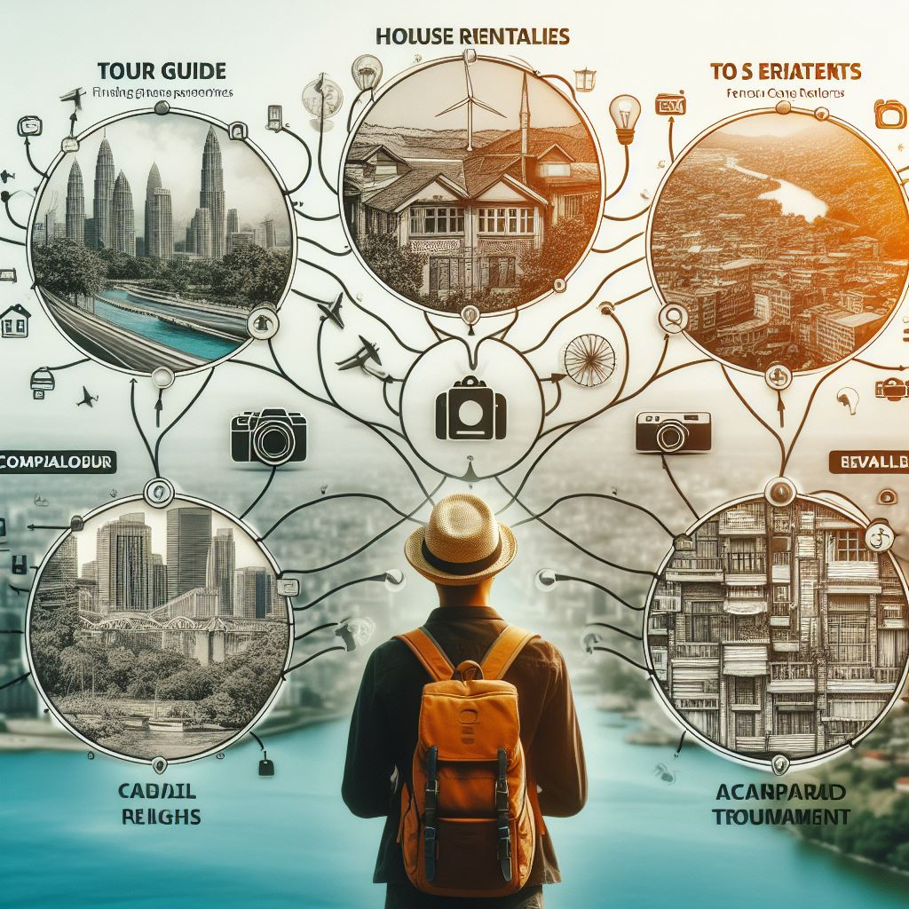

**Chapter Two**

Literature Review

**Background**

Traveling on a low budget is a common desire and challenge for many people who want to explore the world without spending too much money. However, traveling on a low budget can also entail various difficulties and limitations, such as finding suitable companions, accommodation, transportation, and equipment for the trips. Moreover, traveling on a low budget can also affect the quality and convenience of the travel experience, as well as the safety and security of the travelers.

According to some web sources (“1”,”2”,”3”), there are several factors that influence the cost and feasibility of traveling on a low budget, such as the destination, the season, the duration, the activities, and the personal preferences of the travelers. Some destinations are more expensive than others, some seasons are more crowded and costly than others, some durations are

more optimal and affordable than others, some activities are more enjoyable and worthwhile than others, and some personal preferences are more compatible and flexible than others. Therefore, traveling on a low budget requires careful planning, research, and compromise from the travelers.

There are also various tips and tricks that can help travelers to travel on a low budget, such as using the sharing economy, booking error fares, doing DIY tours, cooking their own meals, using public transportation, joining free or cheap activities, and so on (“1”,”2”,”3”). However, these tips and tricks may not always be available or applicable in every situation, and they may also entail some risks or drawbacks for the travelers. For example, using the sharing economy may expose the travelers to unreliable or dishonest providers or hosts, booking error fares may result in canceled or changed flights, doing DIY tours may miss out on some important or hidden information or attractions, cooking their own meals may limit the opportunity to try local cuisines, using public transportation may be inconvenient or unsafe in some places, joining free or cheap activities may be crowded or boring, and so on.

Therefore, traveling on a low budget is a problem that needs to be addressed by providing comprehensive travel assistance that can offer reliable and affordable solutions for the needs and preferences of the travelers. Such travel assistance can include tour guides, house rentals, car rentals, and camera rentals in various locations. These components can enhance the travel experience of low-budget travelers by improving their satisfaction and enjoyment of their trips. They can also make travel experiences more accessible and appealing for all. The project is based on a thorough review of the literature on low-budget travel, travel assistance, and travel satisfaction. The literature review revealed that there is a gap in the existing research on how to provide comprehensive travel assistance for low-budget travelers that covers all aspects of their travel needs. The literature review also showed that there is a need for more empirical studies on how travel assistance affects the travel experience and satisfaction of low-budget travelers. Therefore, this project aims to fill this gap by developing and testing a comprehensive travel assistance model for low-budget travelers.

Traveling on a low budget is a common challenge for many people who want to explore the world without compromising on quality or convenience. However, there are various ways to overcome this challenge and have a satisfying and enjoyable travel experience. This project aims to provide comprehensive travel assistance for low-budget travelers by offering them four main services: tour guides, house rentals, car rentals, and camera rentals. These services are designed to enhance the travel experience of low-budget travelers by offering them reliable and affordable solutions for their needs. The project also aims to make travel experiences more accessible and appealing for all by reducing the costs and barriers of traveling.



**Review of Relevant Literature, Theories, & Methodologies**

A comprehensive review of relevant literature reveals several key trends and insights into the development and use of travel assistance applications. Studies indicate a growing demand for integrated platforms that offer multiple services to enhance user convenience. Theories related to user experience (UX) design, mobile application development, and the sharing economy are particularly relevant. Methodologies such as Agile development and user-centered design (UCD) are commonly employed in developing such applications.

**Analysis of existing solutions or similar projects**

There are many existing solutions in the market that cater to the needs of low-budget travelers, such as:

* Online platforms that offer cheap flights, accommodation, transportation, activities, or attractions, such as [Sky scanner], [Hostel world], [Uber], or [Group on]
* Online communities that connect travelers with locals or other travelers who can offer advice, support, or hospitality, such as [Couch surfing], [Trip Advisor], [Lonely Planet], or [Meet up]
* Online courses that teach travelers how to travel on a low budget, such as [Nomadic Matt’s Superstar Blogging], [Travel Hacking 101], or [The Ultimate Travel Writer’s Program]
* Online tools that help travelers manage their budget, itinerary, or documents, such as [Trail Wallet], [TripIt], or [Google Translate]

However, there are also some gaps in the market that limit the options and opportunities for low-budget travelers, such as:

* Lack of personalized and reliable tour guides who can offer local insights and experiences
* Lack of affordable and comfortable house rentals that match the preferences and requirements of travelers
* Lack of competitive and convenient car rentals that allow travelers to explore their destinations at their own pace
* Lack of accessible and quality camera rentals that enable travelers to capture memorable moments during their trips

**Identification of Gaps or Opportunities for Improvement**

The review of existing solutions reveals several gaps and opportunities for improvement:

Integration: There is a lack of a unified platform that integrates multiple travel services, which can streamline the user experience and reduce the need for multiple applications.

Affordability: Many existing platforms do not cater specifically to low-budget travelers, creating a demand for more cost-effective solutions.

Usability: Ensuring a seamless and intuitive user experience across different services is essential for user satisfaction.

Scalability: The ability to scale the application to accommodate additional services and features is crucial for long-term success.

**Chapter Three**

**System-Analysis**



**User Requirements**

**Functional Requirements**

**For Travelers**

1. Search and Filter: Ability to search and filter tour guides, house rentals, car rentals, and camera rentals based on various criteria such as location, price, availability, and ratings.

2. Booking and Reservation: Functionality to book and reserve selected services, including tour guides, accommodations, cars, and cameras, ensuring a seamless booking experience.

3. Payment Processing: Secure and convenient payment options for booking services, providing multiple methods for processing payments.

4. Communication: In-app messaging or chat feature to communicate with service providers (tour guides, rental owners) before, during, and after the service. This ensures clear communication and coordination.

5. Reviews and Ratings: Ability to rate and review service providers based on their experiences, helping other travelers make informed decisions and maintaining high service standards.

6. Profile Management: Create and manage user profiles, including personal information, preferences, and booking history. This feature allows users to personalize their experience and keep track of their interactions.

7. Notifications: Receive notifications about booking confirmations, updates, and reminders, ensuring users are always informed about the status of their bookings and other important events.

8. AI Chatbot Assistance: Access to an AI chatbot for travel-related inquiries and support, providing instant answers and assistance to enhance the user experience.

9. Weather Information: View real-time weather forecasts for travel destinations, helping travelers plan their trips and activities accordingly.

10. In-App Chat: Communicate with other travelers within the app to exchange tips, recommendations, and experiences, fostering a sense of community.

11. Google Maps Integration: Utilize Google Maps for navigation and location services, making it easy for travelers to find accommodations, attractions, and other travel services.

**For Tour Guides**

1. Profile Creation and Management: Create and manage profiles showcasing their expertise, experience, availability, and pricing, helping travelers find the right guide for their needs.

2.Tour Creation and Management: Create and manage tour packages, including itineraries, descriptions, and pricing. This allows tour guides to offer customized experiences to travelers.

3. Booking Management: Accept or decline booking requests from travelers, ensuring control over their schedule and commitments.

4. Communication: Communicate with travelers through in-app messaging or chat, facilitating coordination and answering any questions travelers may have.

5. Reviews and Ratings: Receive and view ratings and reviews from travelers, providing feedback that can help improve their services and attract more clients.

6.Payment Management: Receive payments for completed tours, ensuring a secure and efficient transaction process.

**For Service Providers (Car/Camera Rentals)**

1.Listing Creation and Management: Create and manage listings for their services, including descriptions, photos, availability, and pricing. This feature helps service providers showcase their offerings effectively.

2.Booking Management: Accept or decline booking requests from travelers, allowing service providers to manage their inventory and schedule efficiently.

3. Communication: Communicate with travelers through in-app messaging or chat, ensuring clear communication about rental details and arrangements.

4. Reviews and Ratings: Receive and view ratings and reviews from travelers, helping to maintain high service standards and attract more customers.

5. Payment Management: Receive payments for completed rentals, providing a secure and reliable way to handle transactions.

By meeting these functional requirements, Guide Go aims to provide a comprehensive, user-friendly platform that enhances the travel experience for all users involved.

**Non-Functional Requirements**

Performance: The system should be responsive and efficient, with minimal loading times.

Reliability: The system should be available and accessible 24/7 with minimal downtime.

Security: Robust security measures should be implemented to protect user data and financial transactions.

Usability: The user interface should be intuitive, user-friendly, and easy to navigate.

Scalability: The system should be able to handle a growing number of users and services.

Compatibility: The application should be compatible with various devices and operating systems (iOS and Android).

**System Requirements**

Guide Go is designed to be a robust and reliable application, requiring specific hardware, software, and network components to ensure optimal performance and security. The system requirements are categorized as follows:

**Hardware**

1. Servers: High-performance servers to host the application and database, ensuring smooth operation and quick response times for users.

2. Storage: Sufficient storage capacity for user data, images, and other content. This ensures that all user-generated and system data are stored efficiently without compromising performance.

3. Database: Firebase is used as the primary database solution. It offers real-time database capabilities, ensuring that data is updated and synchronized across all users instantaneously.

**Software**

1. Framework: The application is developed using Flutter, an open-source framework by Google. Flutter allows for the creation of cross-platform applications (Android and iOS) using a single codebase, offering rich and attractive user interfaces along with high performance and flexibility.

2.Cloud Services: Firebase is utilized for various backend services, including:

* Real-time Database: For storing and synchronizing data in real-time across all clients.
* Authentication: For handling user sign-in/sign-up processes securely.
* Storage: For storing user-uploaded images and other media.

Network

1. Internet Connectivity: Reliable internet connectivity is essential for both users and service providers to ensure smooth access to the application and its services. This includes stable connections for data retrieval, booking processes, and real-time communication.

2. Secure Communication Protocols: The application uses HTTPS for secure data transmission, ensuring that all communications between the user’s device and the server are encrypted. This is critical for protecting sensitive information such as personal details, payment information, and login credentials.

By meeting these system requirements, Guide Go ensures a secure, high-performance, and reliable platform for all users, providing seamless travel experience enhanced by modern technologies and robust infrastructure.

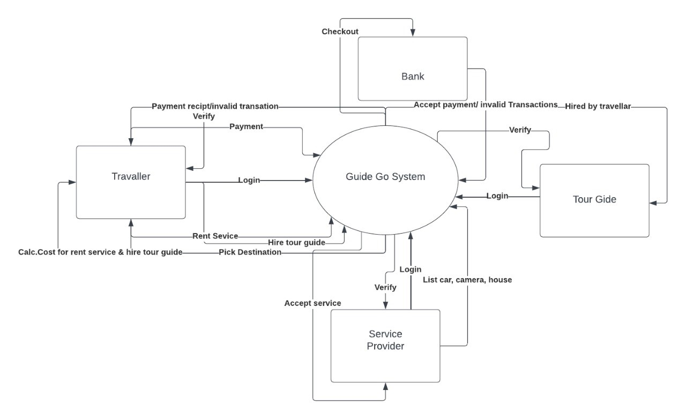 **Context Diagram**

**Overview:**

The Guide Go System is designed to facilitate seamless travel experiences for users. It acts as an intermediary between various entities involved in travel services. Below, we break down the key components of this context diagram:

* **Product (Guide Go System):**
  + - The central focus of our system.
    - Responsible for managing travel-related processes and interactions.
    - Encompasses job roles, responsibilities, and internal processes.
* **External Entities:**
* These entities interact with the Guide Go System:
  + - **Travelers**: Individuals seeking travel services.
    - **Banks**: Financial institutions handling transactions.
    - **Tour Guides**: Professionals providing travel guidance.
    - **Service Providers**: Entities offering accommodations, transportation, and other services.

**Elements Explained:**

* **Product (Guide Go System):**
* **Scope:** The entire travel service system.
* **Boundaries:** Defined by the system’s interactions with external entities.
* **Responsibilities:**
  + - Managing bookings, payments, and travel arrangements.
    - Ensuring a smooth experience for travelers.
    - Coordinating with banks, tour guides, and service providers.
* **External Entities:**
* **Travelers:**
  + - Seek travel services (booking flights, hotels, tours).
    - Interact with the system to plan their trips.
    - Provide essential data (preferences, payment details).
* **Banks:**
  + Handle financial transactions (payments, refunds).
  + Communicate with the system for secure transactions.
* **Tour Guides:**
* Offer expertise and personalized guidance to travelers.
* Collaborate with the system to organize tours.
* **Service Providers:**
  + Provide accommodations, transportation, and other services.
  + Engage with the system to offer their services to travelers.
* **Purpose and Benefits:**
* The context diagram ensures that the Guide Go System aligns with project requirements and external constraints.
* By focusing on external interactions, it reduces risks and ensures relevance.
* During planning, this diagram helps stakeholders understand the landscape and make informed decisions.

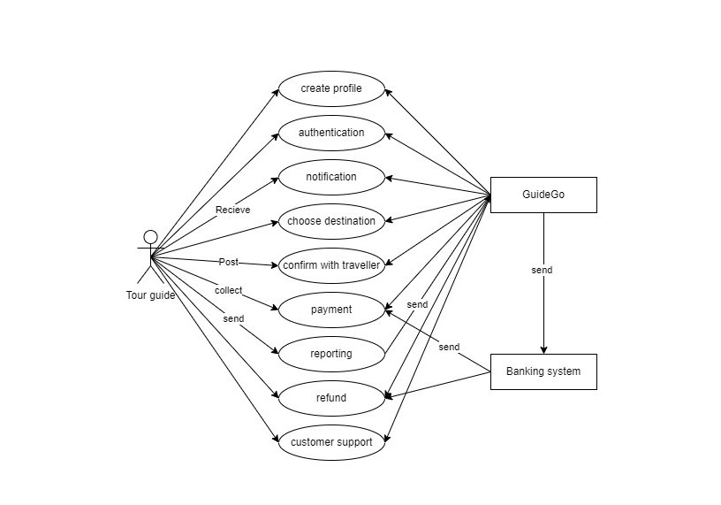**Use case**

Figure (1)

**Overview:** The use case diagram illustrates the interactions and functionalities within the “Guide-Go” system. This system facilitates communication between tour guides and the banking system, enabling seamless user experiences during guided tours.

* **Actors:**
* **Tour Guide**: Represents the human tour guide who interacts with the system.
* **Banking System**: Represents the external banking infrastructure that handles financial transactions.
* **Use Cases:**
* **Profile Creation (Tour Guide)**:
  + The tour guide creates a profile by providing personal details, credentials, and expertise.
  + The system validates the information and stores the profile securely.
* **Authentication (Tour Guide)**:
  + The tour guide logs in using their credentials.
  + The system verifies the login details and grants access to authorized features.
* **Notifications (Tour Guide)**:
  + The system sends notifications to tour guides regarding upcoming tours, changes, or urgent messages.
  + Tour guides receive notifications through email or in-app alerts.
* **Destination Choice (Tour Guide)**:
  + The tour guide selects a destination for a guided tour.
  + The system provides relevant information about the chosen location, including historical context, landmarks, and safety guidelines.
* **Payment Processing (Banking System)**:
  + When a tour is booked, the system initiates payment processing.
  + The banking system securely handles transactions, deducting tour fees from the user’s account.
* **Reporting (Tour Guide)**:
  + Tour guides generate reports on completed tours, user feedback, and earnings.
  + These reports assist in performance evaluation and business planning.
* **Customer Support (Tour Guide)**:
  + Tour guides can seek assistance through the system.
  + The system routes queries to customer support representatives for timely resolution.
* **Relationships:**
* The tour guide interacts with multiple use cases, emphasizing their central role.
* The banking system collaborates with the payment processing use case, ensuring financial integrity.

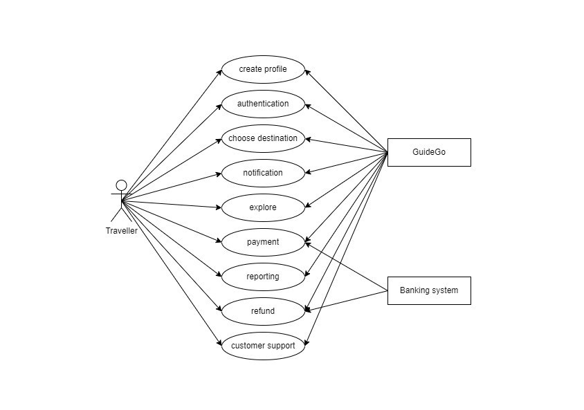

Figure (2)

* **Overview**

The flowchart illustrates the journey of a traveler using the ‘‘Guide-Go’’ system, from profile creation to payment processing. It emphasizes key touchpoints and interactions that enhance the overall user experience.

* **Actors:**
* **Traveler**: Represents the end user seeking guided tours and experiences.
* ‘‘Guide-Go’’ **System**: Refers to the travel platform that connects travelers with tour guides and manages bookings.
* **Banking System**: External infrastructure responsible for secure financial transactions.
* **Steps in the User Journey**

1. **Profile Creation (Traveler)**:
   * The traveler creates a personalized profile on

‘‘Guide-Go’’.

* + Information includes name, contact details, preferences, and interests.
  + The system validates and stores the profile securely.

1. **Authentication (Traveler)**:
   * Upon returning to ‘‘Guide-Go’’, the traveler logs in using their credentials.
   * The system verifies the login details and grants access to personalized features.
2. **Browse Tours (Traveler)**:
   * Travelers explore available guided tours.
   * They filter by location, theme, duration, and guide ratings.
   * The system displays relevant tour options.
3. **Select Tour (Traveler)**:
   * The traveler chooses a specific tour.
   * Details include date, time, itinerary, and pricing.
   * The system confirms availability and reserves the spot.
4. **Payment Processing (Banking System)**:
   * When booking a tour, the system initiates payment.
   * The banking system securely processes the transaction.
   * The traveler’s account is debited, and the tour is confirmed.
5. **Tour Experience (Traveler)**:
   * On the tour day, the traveler meets the guide.
   * The system provides real-time updates, meeting points, and tour information.
   * Travelers enjoy the guided experience.
6. **Feedback and Ratings (Traveler)**:
   * After the tour, travelers provide feedback and ratings.
   * The system aggregates reviews to improve service quality.
   * Positive ratings enhance guide visibility.
7. **Booking History (Traveler)**:
   * Travelers can view their past and upcoming bookings.
   * The system maintains a history for reference.
8. **Customer Support (Traveler)**:
   * If issues arise, travelers seek assistance through the system.
   * Customer support responds promptly.

* **Relationships**
* The ‘‘Guide-Go’’ system orchestrates interactions between travelers, guides, and the banking system.
* Seamless transitions enhance user satisfaction.

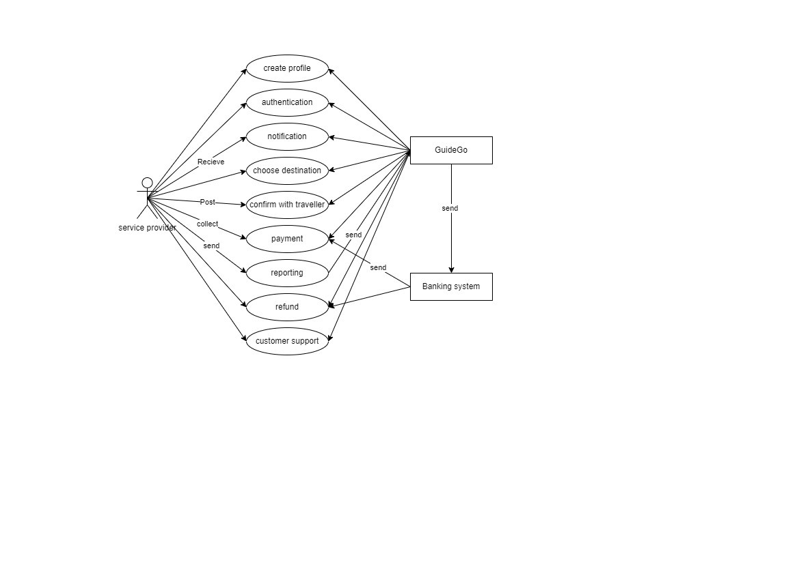

Figure (3)

* **Overview**

The flowchart illustrates the journey of a traveler using the ‘‘Guide-Go’’ system, emphasizing key touchpoints and interactions that enhance the overall user experience.

* **Actors**

1. **Traveler**: Represents the end user seeking guided tours and experiences.
2. ‘‘Guide-Go’’ **System**: Refers to the travel platform that connects travelers with tour guides and manages bookings.
3. **Banking System**: External infrastructure responsible for secure financial transactions.
4. **Customer Support**: Represents the support team assisting travelers during their journey.

* **Steps in the User Journey:**

1. **Profile Creation (Traveler)**:
   * The traveler creates a personalized profile on Guide Go.
   * Information includes name, contact details, preferences, and interests.
   * The system validates and stores the profile securely.
2. **Authentication (Traveler)**:
   * Upon returning to ‘‘Guide-Go’’, the traveler logs in using their credentials.
   * The system verifies the login details and grants access to personalized features.
3. **Browse Tours (Traveler)**:
   * Travelers explore available guided tours.
   * They filter by location, theme, duration, and guide ratings.
   * The system displays relevant tour options.
4. **Select Tour (Traveler)**:
   * The traveler chooses a specific tour.
   * Details include date, time, itinerary, and pricing.
   * The system confirms availability and reserves the spot.
5. **Payment Processing (Banking System)**:
   * When booking a tour, the system initiates payment.
   * The banking system securely processes the transaction.
   * The traveler’s account is debited, and the tour is confirmed.
6. **Tour Experience (Traveler)**:
   * On the tour day, the traveler meets the guide.
   * The system provides real-time updates, meeting points, and tour information.
   * Travelers enjoy the guided experience.
7. **Feedback and Ratings (Traveler)**:
   * After the tour, travelers provide feedback and ratings.
   * The system aggregates reviews to improve service quality.
   * Positive ratings enhance guide visibility.
8. **Booking History (Traveler)**:
   * Travelers can view their past and upcoming bookings.
   * The system maintains a history for reference.
9. **Customer Support Interaction (Traveler)**:
   * If issues arise during the journey, travelers seek assistance through the system.
   * Customer support responds promptly, addressing concerns.

* **Relationships**
* The ‘‘Guide-Go’’ system orchestrates interactions between travelers, guides, and the banking system.
* Seamless transitions enhance user satisfaction.

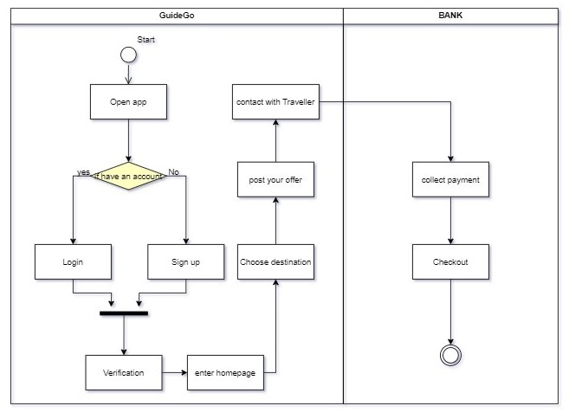**Activity Diagram**

Figure (4)

* **Overview**

The activity diagram represents the dynamic behavior of the ‘‘Guide-Go’’ app, focusing on user interactions and system processes. It outlines the flow from app launch to payment collection, ensuring a seamless user experience.

* **Key Elements**

1. **Start (Open App)**:
   * The process begins when the user opens the

‘‘Guide-Go’’ app.

* + The system initializes and displays the login screen.

1. **User Verification (Login)**:
   * The user enters login credentials (username and password).
   * The system verifies the credentials against the database.
   * If valid, the user gains access; otherwise, an error message is displayed.
2. **Homepage Navigation**:
   * Upon successful login, the user enters the homepage.
   * The system presents options such as browsing tours, viewing bookings, and accessing customer support.
3. **Browse Tours**:
   * The user explores available guided tours.
   * Filters (location, theme, duration) help narrow down choices.
   * The system displays relevant tour options.
4. **Select Tour**:
   * The user chooses a specific tour.
   * Details include date, time, itinerary, and pricing.
   * The system confirms availability and reserves the spot.
5. **Payment Collection (Bank Interaction)**:
   * When booking a tour, the system initiates payment.
   * The user’s bank account is debited securely.
   * The system confirms successful payment.
6. **Tour Experience**:
   * On the tour day, the user meets the guide.
   * Real-time updates (meeting points, tour info) enhance the experience.
   * The user enjoys the guided tour.
7. **Feedback and Ratings**:
   * After the tour, the user provides feedback and ratings.
   * Positive ratings improve guide visibility.
   * The system aggregates reviews for service enhancement.
8. **Booking History**:
   * Users can view past and upcoming bookings.
   * The system maintains a history for reference.
9. **Customer Support Interaction**:
   * If issues arise during the journey, users seek assistance.
   * Customer support responds promptly, addressing concerns.

* **Relationships**
* The ‘Guide-Go’’ app orchestrates interactions between users, guides, and the banking system.

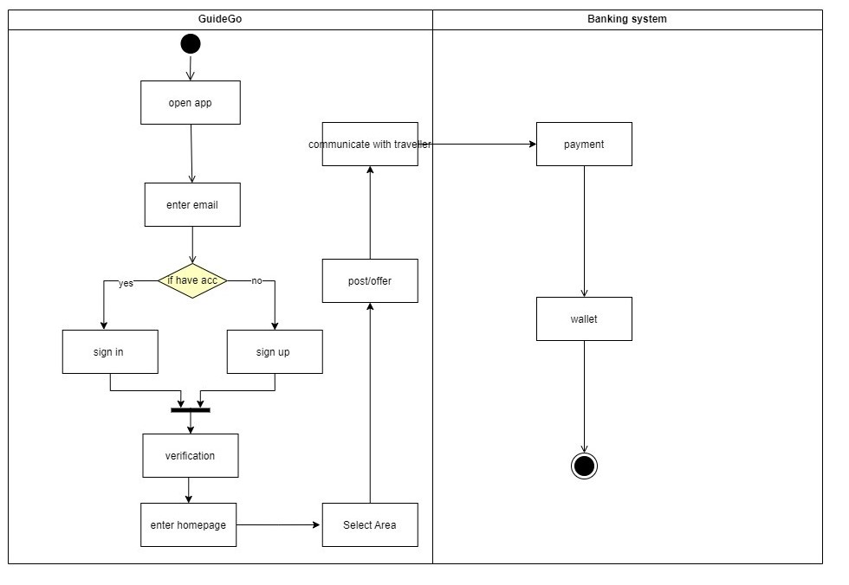Seamless transitions enhance user satisfaction.

Figure (5)

* **Overview**

The activity diagram represents the dynamic behavior of the ‘‘Guide-Go’’ app, focusing on user interactions and system processes. It outlines the flow from app launch to payment collection, ensuring a seamless user experience.

* **Key Elements**

1. **Start (Open App)**:
   * The process begins when the user opens the

‘‘Guide-Go’’ app.

* + The system initializes and displays the login screen.

1. **User Verification (Login)**:
   * The user enters login credentials (username and password).
   * The system verifies the credentials against the database.
   * If valid, the user gains access; otherwise, an error message is displayed.
2. **Homepage Navigation**:
   * Upon successful login, the user enters the homepage.
   * The system presents options such as browsing tours, viewing bookings, and accessing customer support.
3. **Browse Tours**:
   * The user explores available guided tours.
   * Filters (location, theme, duration) help narrow down choices.
   * The system displays relevant tour options.
4. **Select Tour**:
   * The user chooses a specific tour.
   * Details include date, time, itinerary, and pricing.
   * The system confirms availability and reserves the spot.
5. **Payment Collection (Bank Interaction)**:
   * When booking a tour, the system initiates payment.
   * The user’s bank account is debited securely.
   * The system confirms successful payment.
6. **Tour Experience**:
   * On the tour day, the user meets the guide.
   * Real-time updates (meeting points, tour info) enhance the experience.
   * The user enjoys the guided tour.
7. **Feedback and Ratings**:
   * After the tour, users provide feedback and ratings.
   * Positive ratings improve guide visibility.
   * The system aggregates reviews for service enhancement.
8. **Booking History**:
   * Users can view past and upcoming bookings.
   * The system maintains a history for reference.
9. **Customer Support Interaction**:
   * If issues arise during the journey, users seek assistance.
   * Customer support responds promptly, addressing concerns.

* **Relationships**
* The ‘‘Guide-Go’’ app orchestrates interactions between users, guides, and the banking system.
* Seamless transitions enhance user satisfaction.

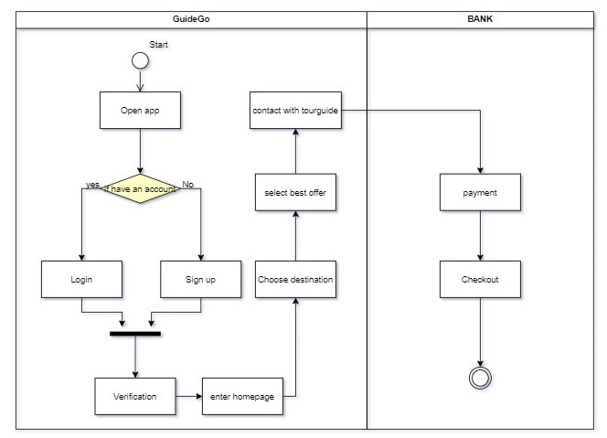

Figure (6)

* **Overview**

The activity diagram represents the dynamic behavior of the ‘‘Guide-Go’’ app, focusing on user interactions and system processes. It outlines the flow from app launch to payment collection, ensuring a seamless user experience.

* **Key Elements**

1. **Start (Open App)**:
   * The process begins when the user opens the ‘‘Guide-Go’’ app.
   * The system initializes and displays the login screen.
2. **User Verification (Login)**:
   * The user enters login credentials (username and password).
   * The system verifies the credentials against the database.
   * If valid, the user gains access; otherwise, an error message is displayed.
3. **Homepage Navigation**:
   * Upon successful login, the user enters the homepage.
   * The system presents options such as browsing tours, viewing bookings, and accessing customer support.
4. **Browse Tours**:
   * The user explores available guided tours.
   * Filters (location, theme, duration) help narrow down choices.
   * The system displays relevant tour options.
5. **Select Tour**:
   * The user chooses a specific tour.
   * Details include date, time, itinerary, and pricing.
   * The system confirms availability and reserves the spot.
6. **Payment Collection (Bank Interaction)**:
   * When booking a tour, the system initiates payment.
   * The user’s bank account is debited securely.
   * The system confirms successful payment.
7. **Tour Experience**:
   * On the tour day, the user meets the guide.
   * Real-time updates (meeting points, tour info) enhance the experience.
   * The user enjoys the guided tour.
8. **Feedback and Ratings**:
   * After the tour, users provide feedback and ratings.
   * Positive ratings improve guide visibility.
   * The system aggregates reviews for service enhancement.
9. **Booking History**:
   * Users can view past and upcoming bookings.
   * The system maintains a history for reference.
10. **Customer Support Interaction**:
    * If issues arise during the journey, users seek assistance.
    * Customer support responds promptly, addressing concerns.

* **Relationships**
* The ‘‘Guide-Go’’ app orchestrates interactions between users, guides, and the banking system.
* Seamless transitions enhance user satisfaction.

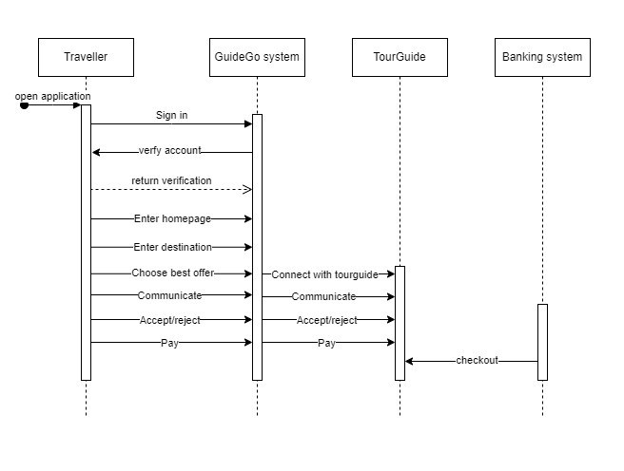**Sequence Diagram**

Figure (10)

* **Overview**

The sequence diagram illustrates the dynamic interactions between various components within the travel application, including the **Traveler**, ‘‘Guide-Go’’ **system**, **Tour Guide**, and **Banking system**.

* **Key Elements**

1. **Traveler (Actor)**:
   * Represents the end user seeking guided tours.
   * Initiates the process by opening the application.
2. ‘‘Guide-Go’’ **System (Boundary Object)**:
   * Manages user interactions and system processes.
   * Verifies Traveler’s account and facilitates communication.
3. **Tour Guide (Actor)**:
   * Represents the tour guide available for bookings.
   * Communicates with Traveler regarding tour offers.
4. **Banking System (External Service)**:
   * Handles secure payment processing.
   * Linked to ‘‘Guide-Go’’ for checkout.

* **Sequence of Actions**

1. **Traveler Opens App**:
   * The process begins when the Traveler opens the travel application.
   * The ‘‘Guide-Go’’ system initializes and displays the login screen.
2. **User Verification (Login)**:
   * The Traveler enters login credentials (username and password).
   * The ‘‘Guide-Go’’ system verifies the credentials against the database.
   * If valid, the Traveler gains access; otherwise, an error message is displayed.
3. **Homepage Navigation**:
   * Upon successful login, the Traveler enters the homepage.
   * The ‘‘Guide-Go’’ system presents options such as browsing tours, viewing bookings, and accessing customer support.
4. **Browse Tours**:
   * The Traveler explores available guided tours.
   * Filters (location, theme, duration) help narrow down choices.
   * The ‘‘Guide-Go’’ system displays relevant tour options.
5. **Select Tour**:
   * The Traveler chooses a specific tour.
   * Details include date, time, itinerary, and pricing.
   * The ‘‘Guide-Go’’ system confirms availability and reserves the spot.
6. **Communication with Tour Guide**:
   * The Traveler communicates with the selected Tour Guide.
   * Offers are accepted or rejected based on availability and preferences.
7. **Payment Processing (Bank Interaction)**:
   * When booking is confirmed, the ‘‘Guide-Go’’ system initiates payment.
   * The Banking system securely processes the transaction.
   * The Traveler’s account is debited, and the tour is confirmed.

* **Relationships**
* The ‘‘Guide-Go’’ system orchestrates interactions between Travelers, Tour Guides, and the Banking system.
* 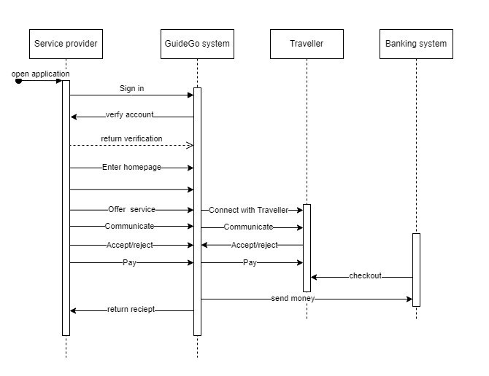Seamless transitions enhance user satisfaction.

Figure (11)

* **Overview**

The sequence diagram illustrates the dynamic interactions between various components within the travel application, including the **Traveler**, ‘‘Guide-Go’’ **system**, **Tour Guide**, and **Banking system**. It outlines the flow of actions during the booking process, communication, and payment handling.

* **Key Elements**

1. **Traveler (Actor)**:
   * Represents the end user seeking guided tours.
   * Initiates the process by opening the application.
2. ‘‘Guide-Go’’ **System (Boundary Object)**:
   * Manages user interactions and system processes.
   * Verifies Traveler’s account and facilitates communication.
3. **Tour Guide (Actor)**:
   * Represents the tour guide available for bookings.
   * Communicates with Traveler regarding tour offers.
4. **Banking System (External Service)**:
   * Handles secure payment processing.
   * Linked to ‘‘Guide-Go’’ for checkout.

* **Sequence of Actions**

1. **Traveler Opens App**:
   * The process begins when the Traveler opens the travel application.
   * The ‘‘Guide-Go’’ system initializes and displays the login screen.
2. **User Verification (Login)**:
   * The Traveler enters login credentials (username and password).
   * The ‘‘Guide-Go’’ system verifies the credentials against the database.
   * If valid, the Traveler gains access; otherwise, an error message is displayed.
3. **Homepage Navigation**:
   * Upon successful login, the Traveler enters the homepage.
   * The ‘‘Guide-Go’’ system presents options such as browsing tours, viewing bookings, and accessing customer support.
4. **Browse Tours**:
   * The Traveler explores available guided tours.
   * Filters (location, theme, duration) help narrow down choices.
   * The ‘‘Guide-Go’’ system displays relevant tour options.
5. **Select Tour**:
   * The Traveler chooses a specific tour.
   * Details include date, time, itinerary, and pricing.
   * The ‘‘Guide-Go’’ system confirms availability and reserves the spot.
6. **Communication with Tour Guide**:
   * The Traveler communicates with the selected Tour Guide.
   * Offers are accepted or rejected based on availability and preferences.
7. **Payment Processing (Bank Interaction)**:
   * When booking is confirmed, the ‘‘Guide-Go’’ system initiates payment.
   * The Banking system securely processes the transaction.
   * The Traveler’s account is debited, and the tour is confirmed.

* **Relationships**
* The ‘‘Guide-Go’’ system orchestrates interactions between Travelers, Tour Guides, and the Banking system.

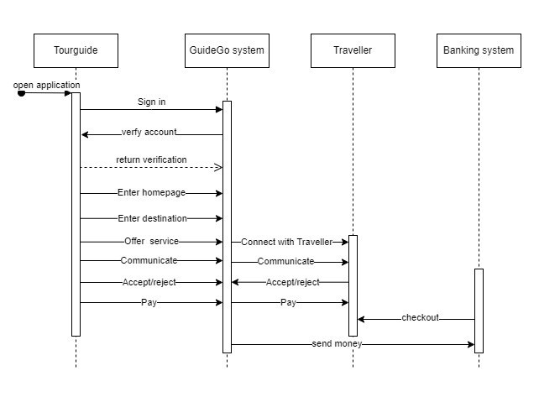

Figure (11)

**Overview**

The sequence diagram illustrates the dynamic interactions between various components within the travel application, including the **Tour Guide**, ‘‘Guide-Go’’ **system**, **Traveler**, and **Banking system**. It outlines the flow of actions during the booking process, communication, and payment handling.

**Key Elements**

1. **Tour Guide (Actor)**:
   * Represents the tour guide available for bookings.
   * Initiates the process by opening the application.
2. **Guide Go System (Boundary Object)**:
   * Manages user interactions and system processes.
   * Verifies the Tour Guide’s account and facilitates communication.
3. **Traveler (Actor)**:
   * Represents the end user seeking guided tours.
   * Communicates with the Tour Guide regarding tour offers.
4. **Banking System (External Service)**:
   * Handles secure payment processing.
   * Linked to ‘‘Guide-Go’’ for checkout.

**Sequence of Actions**

1. **Tour Guide Opens App**:
   * The process begins when the Tour Guide opens the travel application.
   * The ‘‘Guide-Go’’ system initializes and displays the login screen.
2. **User Verification (Login)**:
   * The Tour Guide enters login credentials (username and password).
   * The ‘‘Guide-Go’’ system verifies the credentials against the database.
   * If valid, the Tour Guide gains access; otherwise, an error message is displayed.
3. **Homepage Navigation**:
   * Upon successful login, the Tour Guide enters the homepage.
   * The ‘‘Guide-Go’’ system presents options such as managing tours, viewing bookings, and accessing customer support.
4. **Offering Tours**:
   * The Tour Guide communicates with the Traveler.
   * Offers specific guided tours based on availability and preferences.
   * The Traveler accepts or rejects the tour offers.
5. **Payment Processing (Bank Interaction)**:
   * When the Traveler confirms a tour, the ‘‘Guide-Go’’ system initiates payment.
   * The Banking system securely processes the transaction.
   * The Traveler’s account is debited, and the tour is confirmed.

**Relationships**

* The ‘‘Guide-Go’’ system orchestrates interactions between Tour Guides, Travelers, and the Banking system.
* Seamless transitions enhance user satisfaction.

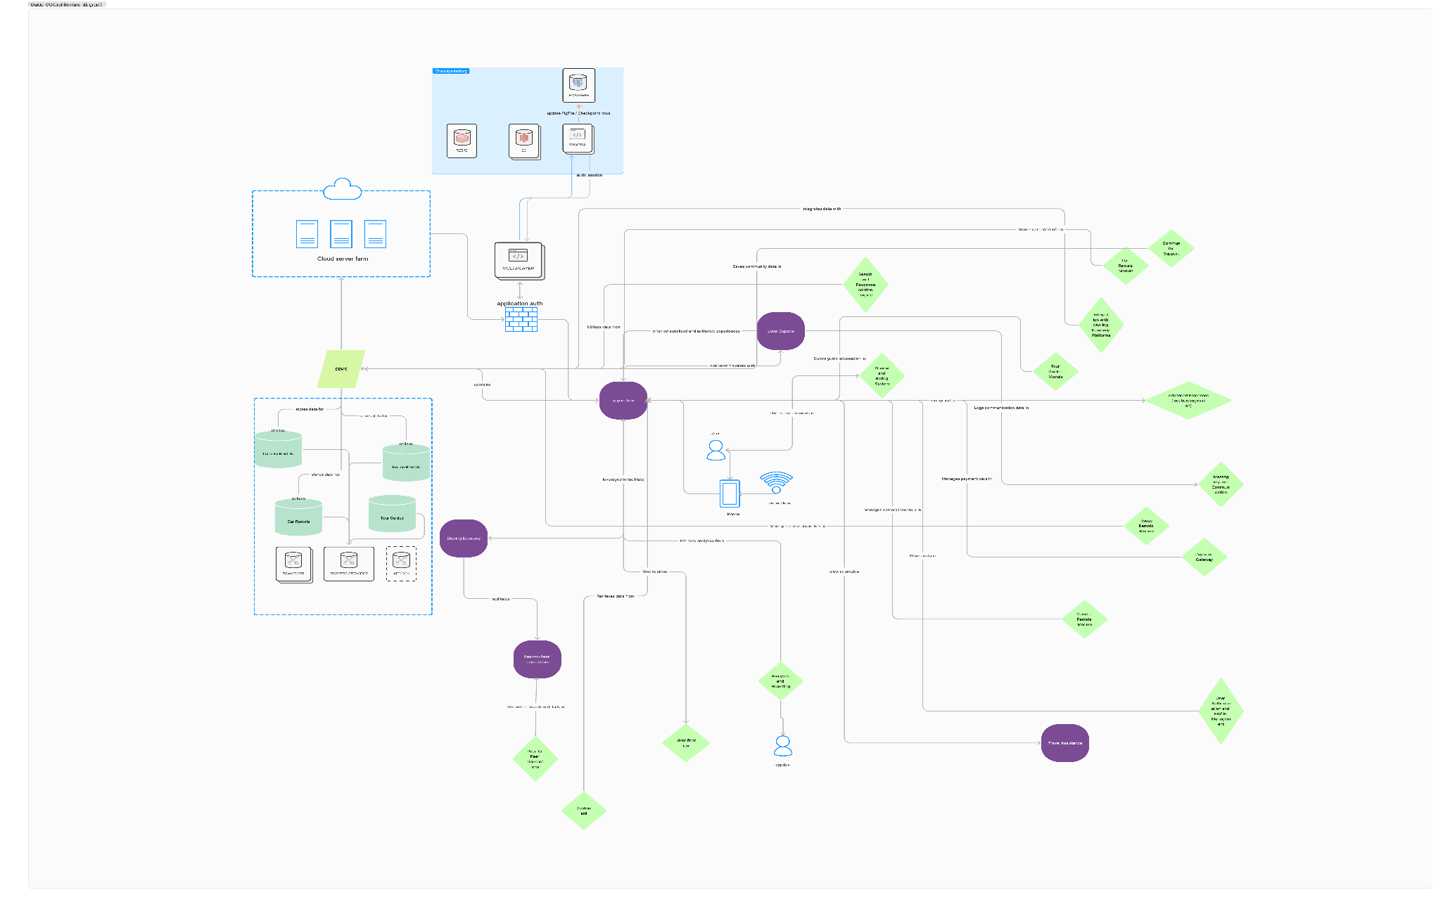**Architecture/Component Diagram**

Figure (12)

* **Architecture Diagram Overview**

The provided architecture diagram offers a comprehensive view of the system’s structure, emphasizing the intricate relationships and data flow between various components. Here are the key elements and their interactions:

1. **User Interfaces (UI)**:
   * Represented by rectangles labeled with specific screens (e.g., “Homepage,” “Booking,” “Payment”).
   * These interfaces serve as entry points for users to interact with the system.
   * Examples include web pages, mobile app screens, and self-service kiosks.
2. **Processes (Rectangles with Rounded Corners)**:
   * Depict various system functionalities and business logic.
   * Examples include booking management, payment processing, and user authentication.
   * The arrows connecting processes indicate the sequential flow of actions.
3. **Data Storage (Databases, Cloud Services)**:
   * Represented by cylinders or cloud icons.
   * Store critical data such as user profiles, bookings, and tour information.
   * Bidirectional arrows signify data retrieval and storage.
4. **Communication Channels (Arrows)**:
   * Connect different components within the system.
   * Represent data exchange, API calls, and messaging.
   * Clear labeling ensures clarity in communication paths.
5. **Security Layers (Firewalls, Authentication)**:
   * Safeguard the system from unauthorized access.
   * Ensure data privacy, integrity, and compliance.
   * Bidirectional arrows highlight secure communication channels.
6. **External Systems (Banking, Tour Guide Services)**:
   * Represented by rectangles positioned outside the main system boundary.
   * Interact with the system for payment processing, tour availability, and communication.
   * Arrows depict external connections and data flows.

* **Key Considerations**
* **Scalability**: The architecture should accommodate increasing user demands without compromising performance.
* **Reliability**: Ensure high availability, fault tolerance, and disaster recovery mechanisms.
* **Security**: Implement robust security measures to protect user data and prevent breaches.
* **Integration**: Seamlessly connect with external services, APIs, and third-party systems.
* **Maintainability**: Design components for easy maintenance, updates, and troubleshooting.



**Chapter Four**

**System-Analysis**

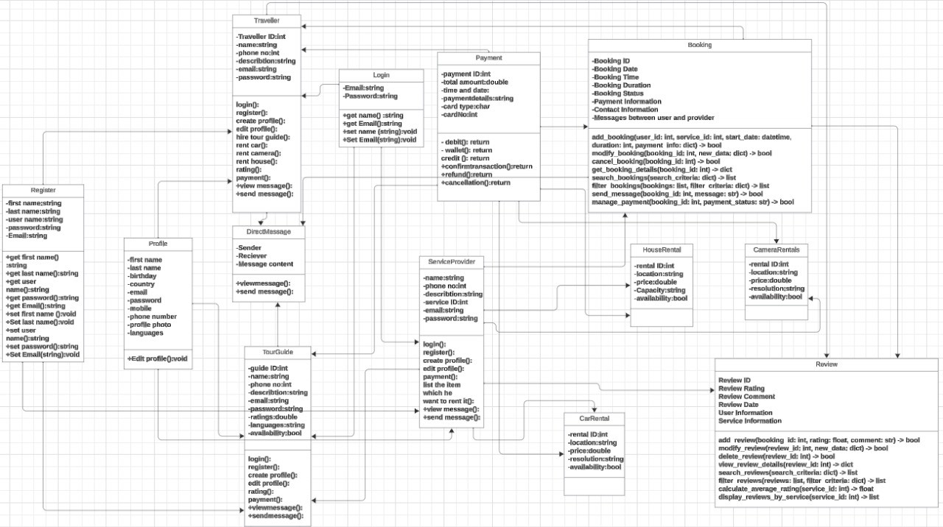**Class Diagram**

Figure (7)

* **Overview**

The class diagram provides a structural blueprint for the system, illustrating the key classes, their attributes, and associations. It ensures a well-organized and efficient software design.

* **Key Elements**

1. **User Profile (Class)**:
   * Represents user information.
   * Attributes: user_Id, username, email, password.
   * Associations: Connected to bookings and payments.
2. **Booking (Class)**:
   * Represents a tour booking.
   * Attributes: booking_Id, tour_Id, user_Id, booking_Date.
   * Associations: Linked to users and tours.
3. **Tour (Class)**:
   * Represents guided tours.
   * Attributes: tour_Id, location, theme, duration.
   * Associations: Connected to bookings.
4. **Payment (Class)**:
   * Represents payment transactions.
   * Attributes: payment_Id, amount, timestamp.
   * Associations: Linked to bookings.
5. **Banking System (Class)**:
   * Represents external payment processing.
   * Attributes: None (external system).
   * Associations: Interacts with payments.
6. **Customer Support (Class)**:
   * Represents support services.
   * Attributes: None (external service).
   * Associations: Provides assistance during the user journey.

* **Relationships**
* **User-Booking Relationship**:
  + Users initiate bookings.
  + Bookings reference user profiles.
* **Booking-Tour Relationship**:
  + Bookings correspond to specific tours.
  + Tours are associated with bookings.
* **Booking-Payment Relationship**:
  + Bookings trigger payment processing.
  + Payments are linked to bookings.
* **Banking System Interaction**:
  + The system communicates with the external banking system for secure payments.
* **Customer Support Interaction**:
  + Users interact with customer support for assistance.

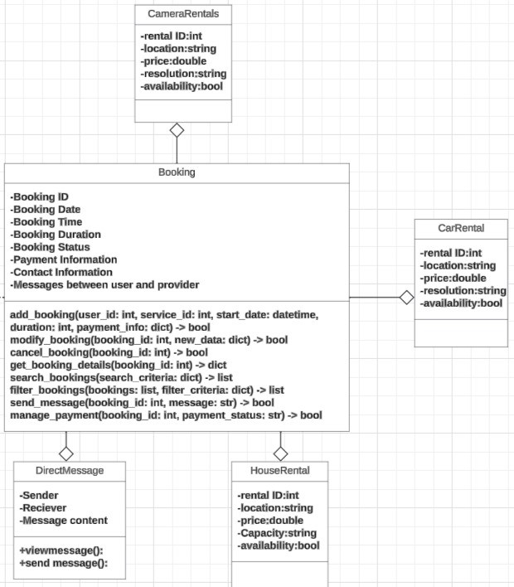

Figure (8)

* **Overview**

The class diagram provides a structural blueprint for the system, illustrating the key classes, their attributes, and associations. It ensures a well-organized and efficient software design.

* **Key Elements**

1. **User Profile (Class)**:
   * Represents user information.
   * Attributes: user_Id, username, email, password.
   * Associations: Connected to bookings and payments.
2. **Booking (Class)**:
   * Represents a tour booking.
   * Attributes: booking_Id, tour_Id, user_Id, booking_Date.
   * Associations: Linked to users and tours.
3. **Tour (Class)**:
   * Represents guided tours.
   * Attributes: tour_Id, location, theme, duration.
   * Associations: Connected to bookings.
4. **Payment (Class)**:
   * Represents payment transactions.
   * Attributes: payment_Id, amount, timestamp.
   * Associations: Linked to bookings.
5. **Banking System (Class)**:
   * Represents external payment processing.
   * Attributes: None (external system).
   * Associations: Interacts with payments.
6. **Customer Support (Class)**:
   * Represents support services.
   * Attributes: None (external service).
   * Associations: Provides assistance during the user journey.

* **Relationships**
* **User-Booking Relationship**:
  + Users initiate bookings.
  + Bookings reference user profiles.
* **Booking-Tour Relationship**:
  + Bookings correspond to specific tours.
  + Tours are associated with bookings.
* **Booking-Payment Relationship**:
  + Bookings trigger payment processing.
  + Payments are linked to bookings.
* **Banking System Interaction**:
  + The system communicates with the external banking system for secure payments.
* **Customer Support Interaction**:
  + Users interact with customer support for assistance.

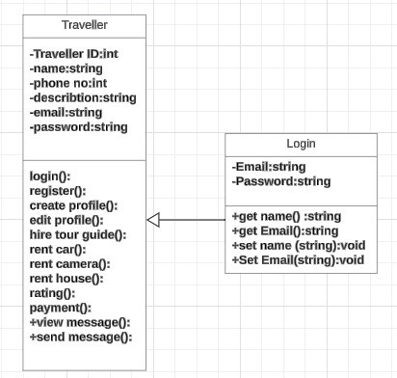

Figure (9)

* **Overview**

The class diagram provides a structural blueprint for the system, illustrating the key classes, their attributes, and associations. It ensures a well-organized and efficient software design.

* **Key Elements**

1. **User Profile (Class)**:
   * Represents user information.
   * Attributes: user_Id, username, email, password.
   * Associations: Connected to bookings and payments.
2. **Booking (Class)**:
   * Represents a tour booking.
   * Attributes: booking_Id, tour_Id, user_Id, bookingDate.
   * Associations: Linked to users and tours.
3. **Tour (Class)**:
   * Represents guided tours.
   * Attributes: tour_Id, location, theme, duration.
   * Associations: Connected to bookings.
4. **Payment (Class)**:
   * Represents payment transactions.
   * Attributes: payment_Id, amount, timestamp.
   * Associations: Linked to bookings.
5. **Banking System (Class)**:
   * Represents external payment processing.
   * Attributes: None (external system).
   * Associations: Interacts with payments.
6. **Customer Support (Class)**:
   * Represents support services.
   * Attributes: None (external service).
   * Associations: Provides assistance during the user journey.

* **Relationships**
* **User-Booking Relationship**:
  + Users initiate bookings.
  + Bookings reference user profiles.
* **Booking-Tour Relationship**:
  + Bookings correspond to specific tours.
  + Tours are associated with bookings.
* **Booking-Payment Relationship**:
  + Bookings trigger payment processing.
  + Payments are linked to bookings.
* **Banking System Interaction**:
  + The system communicates with the external banking system for secure payments.
* **Customer Support Interaction**:
  + Users interact with customer support for assistance.

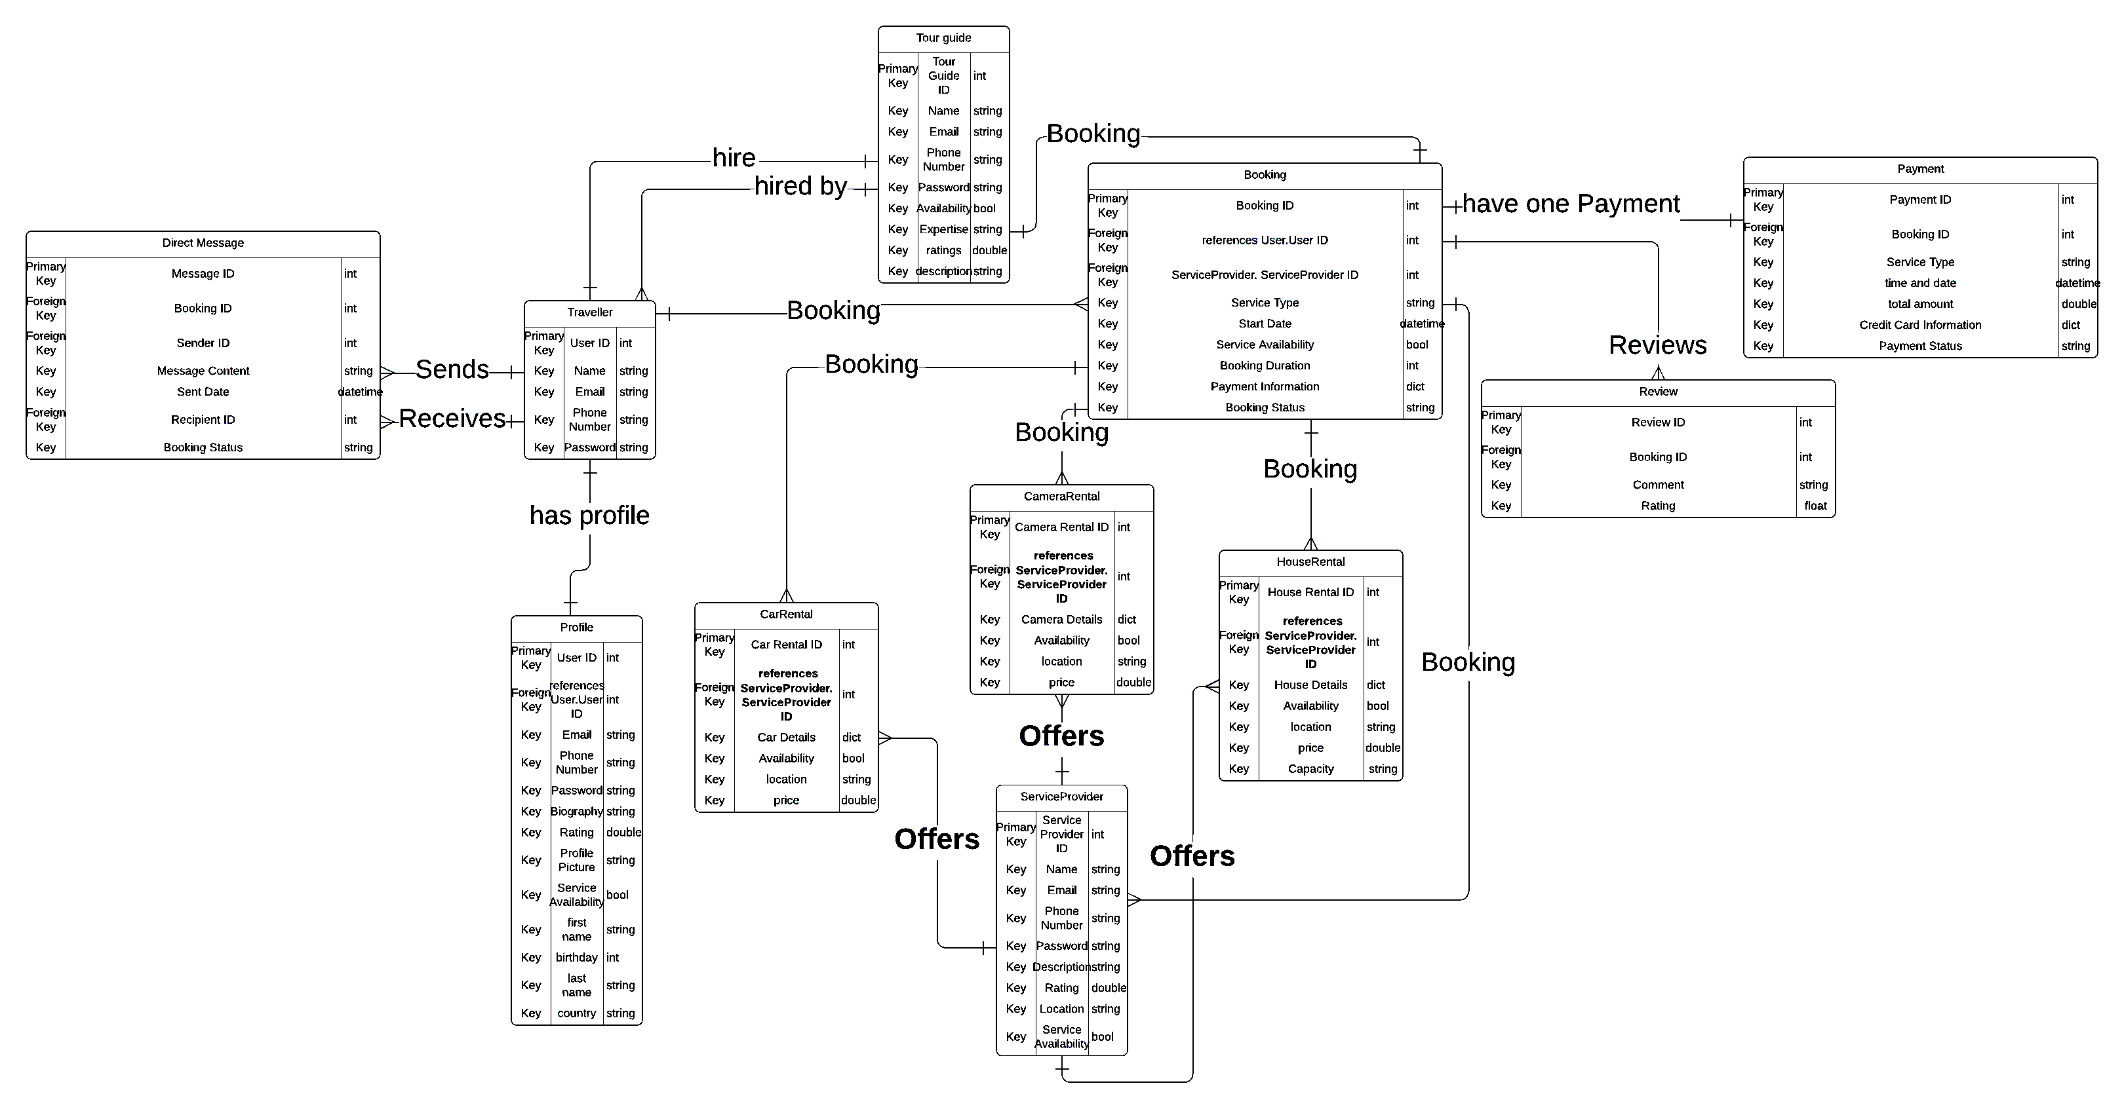

**ERD Diagram**

**Chapter Four**

**System Design**

Figure (15)

* **Overview:**

The following is a detailed description of the Entity-Relationship Diagram (ERD) for the "Guide Go" system, which is designed to facilitate interactions between travelers and service providers such as tour guides, car rental services, camera rental services, and house rental services. This documentation outlines the entities, their attributes, and relationships within the system.

* Entities and Attributes:

1. **Traveler:**

* User ID (Primary Key): Unique identifier for each traveler.
* Name: Traveler's full name.
* Email: Contact email of the traveler.
* Phone Number: Contact phone number of the traveler.
* Password: Secure password for traveler login.

1. **Tour Guide:**

* Tour Guide ID (Primary Key): Unique identifier for each tour guide.
* Name: Tour guide's full name.
* Email: Contact email of the tour guide.
* Phone Number: Contact phone number of the tour guide.
* Password: Secure password for tour guide login.
* Availability: Boolean value indicating availability status.
* Ratings: Average rating given by travelers.
* Description: Description of the tour guide's services.

1. **Service Provider:**

* Service Provider ID (Primary Key): Unique identifier for service providers (car rental, camera rental, house rental).
* Name: Service provider's name.
* Email: Contact email of the service provider.
* Phone Number: Contact phone number of the service provider.
* Password: Secure password for service provider login.
* Ratings: Average rating given by users.
* Location: Location of the service provider.
* Service Availability: Boolean value indicating service availability status.

1. **Profile**

* User ID (Primary Key, Foreign Key references traveler’s ID): Unique identifier for each profile.
* Email: Contact email associated with the profile.
* Phone Number: Contact phone number associated with the profile.
* Password: Secure password for profile login.
* Biography: Brief biography of the user.
* Rating: Average rating received.
* Profile Picture: URL of the profile picture.
* Service Availability: Boolean value indicating service availability status.
* First Name: First name of the user.
* Birthday: Birthday of the user.
* Last Name: Last name of the user.
* Country: Country of the user.

1. **Booking:**

* Booking ID (Primary Key): Unique identifier for each booking.
* User ID (Foreign Key references traveler’s ID): Identifier for the traveler making the booking.
* Service Provider ID (Foreign Key references Service Provider. Service Provider ID): Identifier for the service provider.
* Service Type: Type of service booked (tour guide, car rental, etc.).
* Start Date: Start date of the service.
* Service Availability: Boolean value indicating if the service is available.
* Booking Duration: Duration of the booking.
* Payment Information: Information about the payment.
* Booking Status: Status of the booking (e.g., confirmed, pending).

1. **Camera Rental:**

* Camera Rental ID (Primary Key): Unique identifier for each camera rental.
* Service Provider ID (Foreign Key references Service Provider. Service Provider ID): Identifier for the service provider.
* Camera Details: Details about the camera.
* Availability: Boolean value indicating if the camera is available.
* Location: Location of the camera rental.
* Price: Price of the camera rental.

1. **Car Rental:**

* Car Rental ID (Primary Key): Unique identifier for each car rental.
* Service Provider ID (Foreign Key references Service Provider. Service Provider ID): Identifier for the service provider.
* Car Details: Details about the car.
* Availability: Boolean value indicating if the car is available.
* Location: Location of the car rental.
* Price: Price of the car rental.

1. **House Rental:**

* House Rental ID (Primary Key): Unique identifier for each house rental.
* Service Provider ID (Foreign Key references Service Provider. Service Provider ID): Identifier for the service provider.
* House Details: Details about the house.
* Availability: Boolean value indicating if the house is available.
* Location: Location of the house rental.
* Price: Price of the house rental.
* Capacity: Capacity of the house rental.

1. **Payment:**

* Payment ID (Primary Key): Unique identifier for each payment.
* Booking ID (Foreign Key references Booking. Booking ID): Identifier for the booking associated with the payment.
* Service Type: Type of service for which payment is made.
* Time and Date: Timestamp of the payment.
* Total Amount: Total amount of the payment.
* Credit Card Information: Information about the credit card used for payment.
* Payment Status: Status of the payment (e.g., completed, pending).
* Review
* Review ID (Primary Key): Unique identifier for each review.
* Booking ID (Foreign Key references Booking. Booking ID): Identifier for the booking associated with the review.
* Comment: Comment left by the reviewer.
* Rating: Rating given by the reviewer.

1. **Direct message:**

* Message ID (Primary Key): Unique identifier for each direct message.
* Booking ID (Foreign Key references Booking. Booking ID): Identifier for the booking associated with the message.
* Sender ID (Foreign Key): Identifier for the sender of the message.
* Recipient ID (Foreign Key): Identifier for the recipient of the message.
* Message Content: Content of the message.
* Sent Date: Timestamp of when the message was sent.
* Booking Status: Status of the booking associated with the message.
* **Relationships:**

1. **Traveler and Profile**

* One-to-One: Each traveler has one profile.

1. **Traveler and Direct Message**

* One-to-Many: Each traveler can send and receive multiple direct messages.

1. **Traveler and Booking**

* One-to-Many: Each traveler can have multiple bookings.

1. **Service Provider and Booking**

* One-to-Many: Each service provider can have multiple bookings.

1. **Booking and Payment**

* One-to-One: Each booking has one payment.

1. **Booking and Review**

* One-to-One: Each booking can have one review.

1. **Service Provider and Camera Rental**

* One-to-Many: Each service provider can offer multiple camera rentals.

1. **Service Provider and Car Rental**

* One-to-Many: Each service provider can offer multiple car rentals.

1. **Service Provider and House Rental**

* One-to-Many: Each service provider can offer multiple house rentals.
* **Diagram:**
* This ERD provides a comprehensive overview of the relationships and entities within the "Guide Go" system, detailing how travelers interact with various service providers and the associated bookings, payments, reviews, and communications.

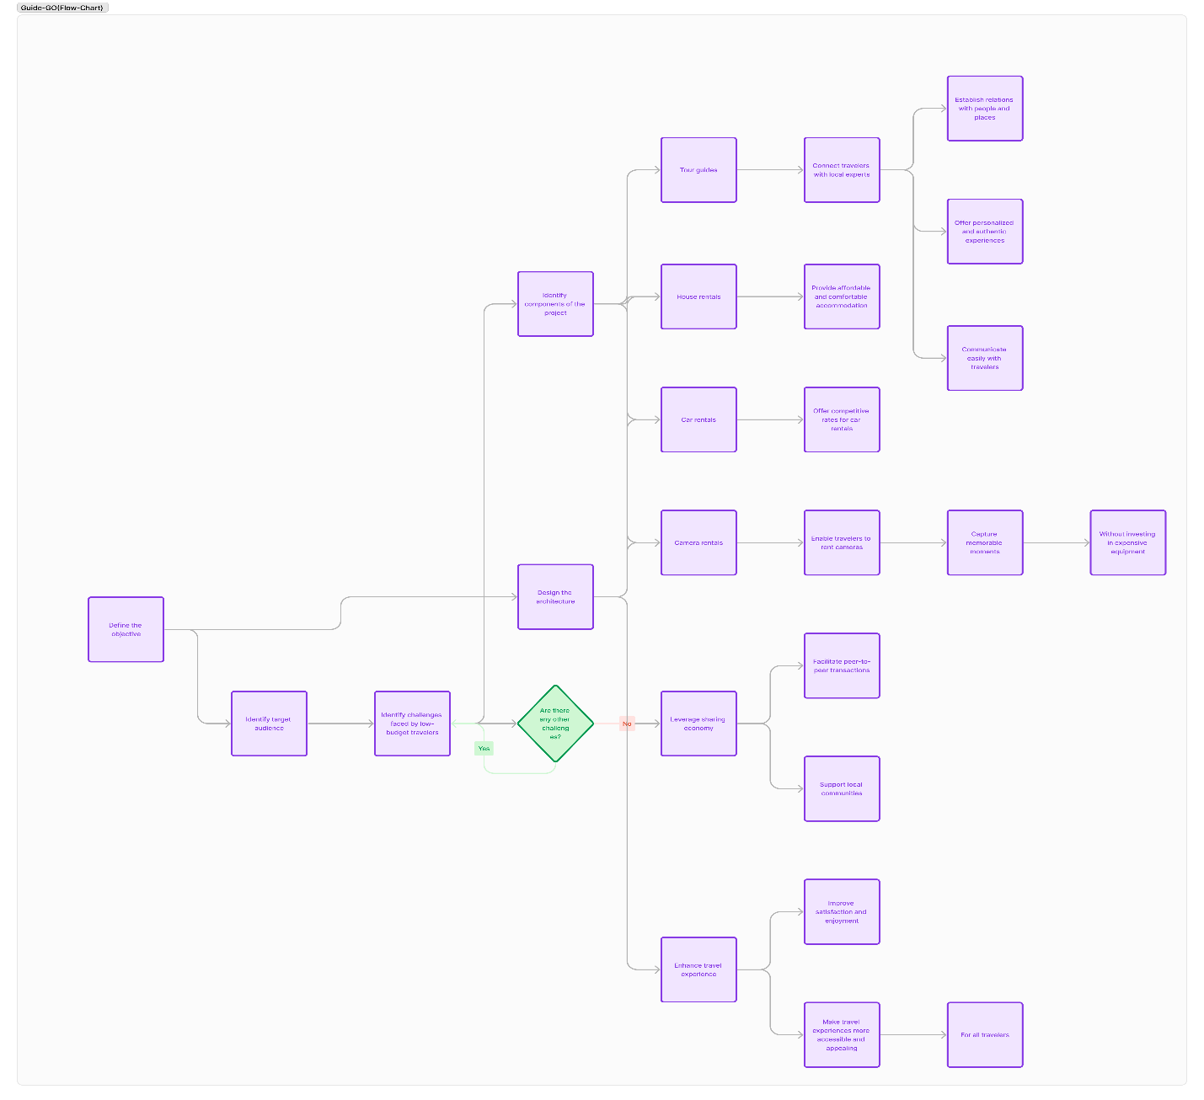**Structure/Flow-chart**

* **Overview**

The provided structure chart illustrates a complex process or system, capturing various steps and decision points. Here are the key elements and their significance:

1. **Process Steps (Purple Rectangles)**:
   * Each purple rectangle represents a specific action or task within the process.
   * These steps are essential for achieving the desired outcome.
   * Examples include data processing, user interactions, or system operations.
2. **Decision Points (Green Diamond Shape)**:
   * The green diamond shapes indicate decision points.
   * At these junctures, the process diverges based on specific conditions or criteria.
   * Decision’s impact subsequent steps.
3. **Arrows (Flow Direction)**:
   * The arrows connecting steps depict the flow of execution.
   * They guide the process from one step to the next.
   * Clear labeling ensures clarity in the sequence.
4. **Complexity and Interconnectedness**:
   * The intricate connections between steps highlight the system’s complexity.
   * Dependencies exist, and certain actions may trigger multiple outcomes.
   * The structure chart captures both linear and branching paths.

* **Key Considerations**
* **Optimization**: Evaluate whether any steps can be streamlined or eliminated to enhance efficiency.
* **Error Handling**: Address potential errors or exceptions at decision points.
* **User Experience**: Consider how the process impacts end users and ensure a seamless experience.
* **Documentation**: Detailed documentation of each step is crucial for system maintenance and troubleshooting.
* **standard flow for user:**

1. **User Opens App:**
   * The user launches the app on their device.
2. **Login/Authentication:**
   * The app prompts the user to log in or authenticate.
   * If new, they can create an account.
3. **Homepage:**
   * Upon successful login, the user lands on the homepage.
   * Here, they can access various features:
   * View available tours.
   * Check existing bookings.
   * Contact customer support.
4. **Browse Tours:**
   * The user explores available guided tours.
   * Filters (location, theme, duration) help narrow down options.
5. **Select Tour:**
   * The user chooses a specific tour.
   * Details include date, time, itinerary, and pricing.
6. **Booking Confirmation:**
   * The user confirms the booking.
   * Payment processing is initiated**.**
7. **Payment Processing:**
   * The app securely processes the payment.
   * Confirmation is sent to the user.
8. **Tour Experience:**
   * The user enjoys the guided tour.



**UI Design**

The splash screen you provided for the Guide Go app can be described as follows for the UI design chapter of your graduation documentation:

**Splash Screen UI Design**

The splash screen for the Guide Go application serves as the introductory interface that users encounter upon launching the app. Its design elements and layout are detailed below:

**1.Background and Layout**:

* + The screen features a clean, white background which provides a minimalist and professional look.
  + A subtle, curved yellow line design adds a touch of dynamism and visual interest without overwhelming the user.

Screen (1)

**2.Branding**:

* + The center of the screen prominently displays the app's logo, which consists of the text "Guide Go GG" accompanied by small graphical elements, including a hat, a map, and an airplane. These elements suggest travel and exploration, aligning with the app's purpose.
  + The logo is rendered in a blue color, creating a strong visual contrast against the white background.

**3.Tagline**:

* + Beneath the logo, the tagline "Your ultimate guide." is displayed in bold, blue text. This succinctly communicates the app's value proposition to the users.

**4.Call to Action**:

* + At the bottom of the screen, a blue button with the text "Sign in" invites users to proceed with accessing the app. The button is large and easily tappable, ensuring good usability on touch devices.
  + Below the primary call to action, a smaller text link reads "Already have an account? Sign in," providing an alternative pathway for returning users to log in.

**5.Status Bar**:

* + The status bar at the top of the screen shows the current time, battery status, and other device indicators, ensuring that essential information remains visible to the user.

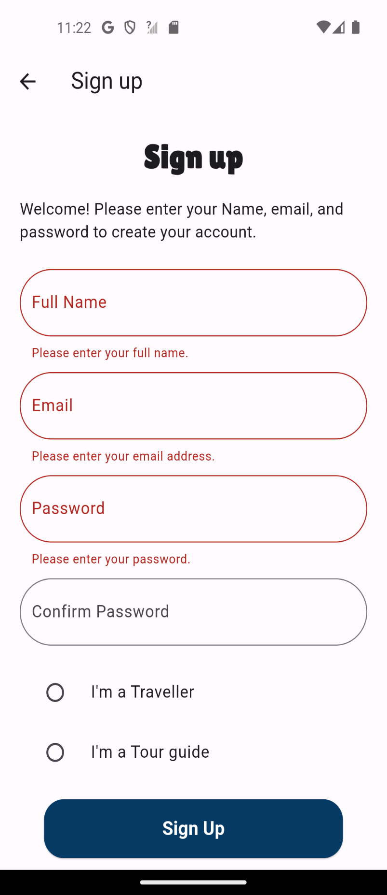

**Sign Up Screen UI Design**

The Sign-Up screen for the Guide Go application is designed to provide a seamless user registration experience. Key elements include:

1. **Header**:
   * A back arrow icon for easy navigation to the previous screen.
   * The title "Sign up" prominently displayed at the top.
2. **Form Fields**:
   * **Full Name**: Input field for the user's full name, with a placeholder "Please enter your full name."
   * **Email**: Input field for the user's email address, with a placeholder "Please enter your email address."
   * **Password**: Input field for the user's password, with a placeholder "Please enter your password."

Screen (2)

* + **Confirm Password**: Input field to confirm the user's password.

1. **User Type Selection**:
   * Two radio buttons to select the user type: "I'm a Traveler" and "I'm a Tour guide."
2. **Submit Button**:
   * 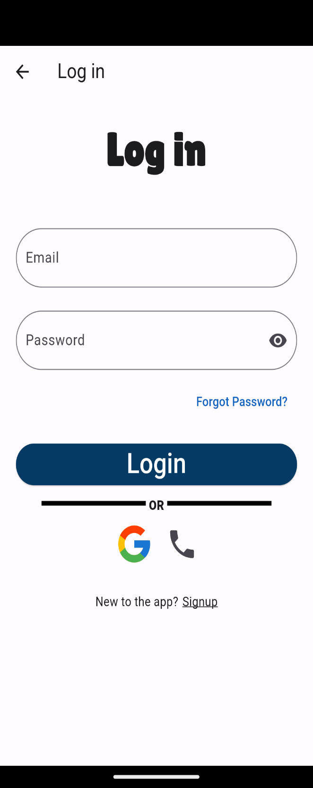A blue "Sign Up" button to submit the registration form.

**Log In Screen UI Design**

The Log In screen for the Guide Go application is designed for quick and easy access. Key elements include:

1. **Header**:
   * A back arrow icon for easy navigation to the previous screen.
   * The title "Log in" prominently displayed at the top.
2. **Form Fields**:
   * **Email**: Input field for the user's email address.
   * **Password**: Input field for the user's password, with an eye icon to toggle password visibility.

Screen (3)

1. **Forgot Password**:

A "Forgot Password?" link for users to reset their password.

1. **Submit Button**:
   * A blue "Login" button to submit the login form.
2. **Alternative Login Options**:
   * Options to log in using Google or phone.
3. **Sign Up Link**:
   * A link to the sign-up page for new users.

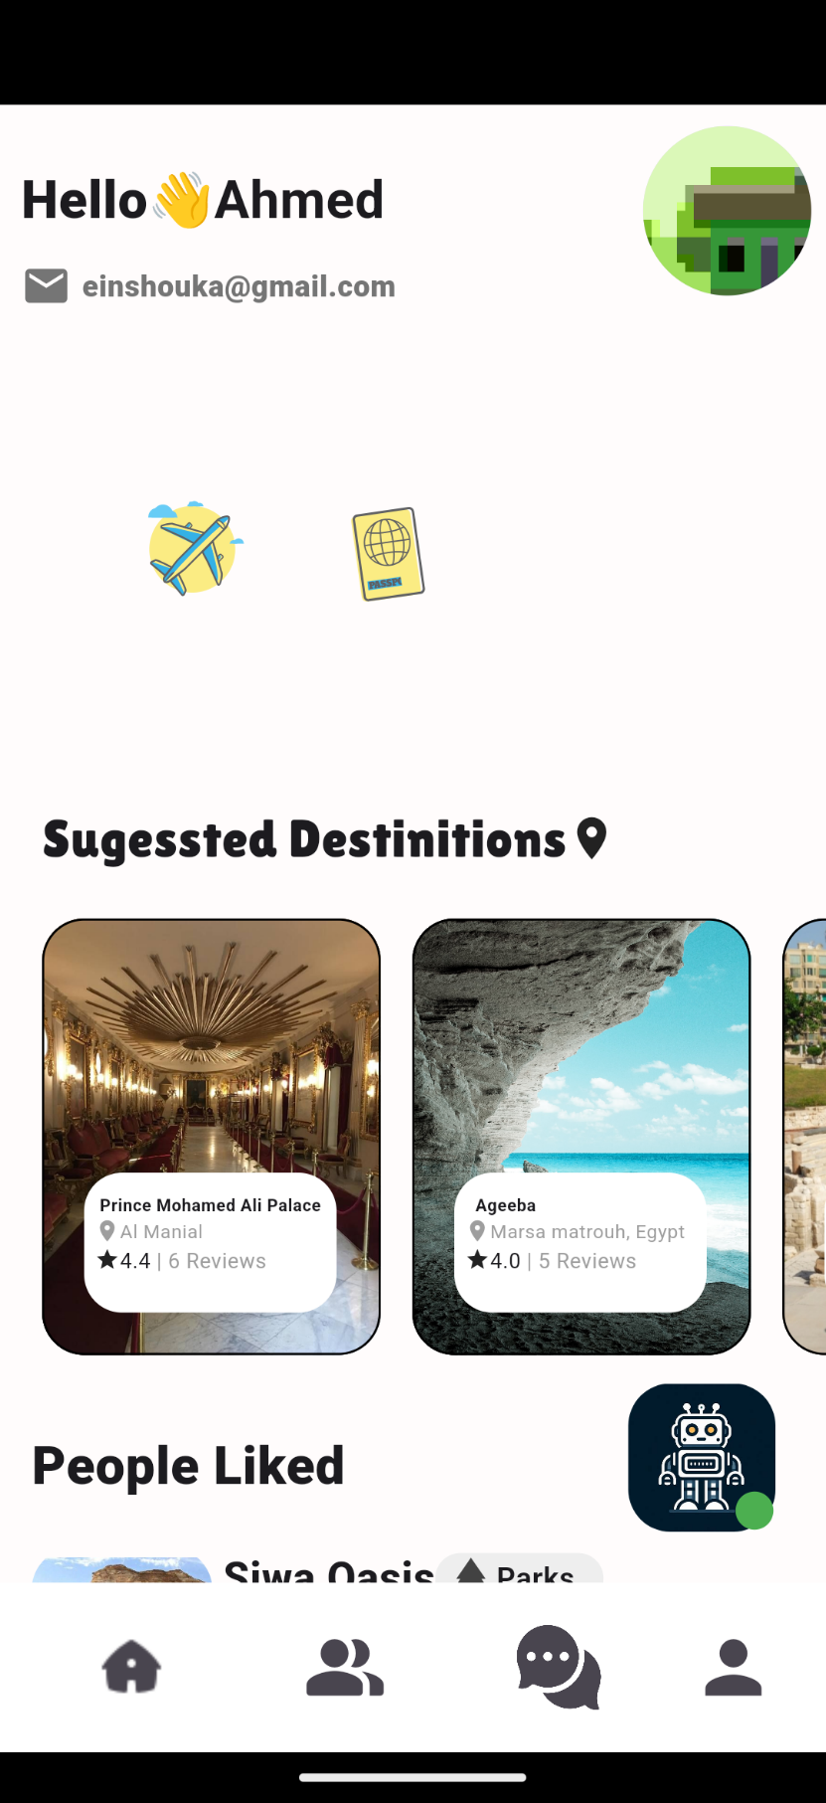**Overview**

This screen is part of a travel and tourism mobile application. It focuses on providing a personalized experience and suggesting destinations to the user. The design emphasizes usability, engagement, and intuitive navigation.

**Top Section**

* **Header**:
  + **Personalized Greeting**: "Hello 👋 Ahmed!" – Provides a warm welcome to the user.
  + **User Email**: "einshoukaa@gmail.com" – Displays the user's email address.
  + **Profile Picture**: A circular profile picture of the user, aligned to the right for easy recognition.

**Icons Section**

* **Category Icons**: A horizontal row of icons for quick access to key travel categories:
  + **Airplane Icon**: Represents travel destinations or flight information.

Screen (4)

* + **Passport Icon**: Denotes travel documentation or visa requirements.

**Suggested Destinations Section**

* **Title**: "Suggested Destinations" – Highlights destinations recommended for the user.
* **Featured Places**: Cards showcasing popular destinations with relevant details:
  + **Prince Mohamed Ali Palace**:
    - **Location**: Al Manial
    - **Rating**: 4.4 stars from 6 reviews.
    - **Image**: Displays a luxurious interior setting, emphasizing cultural and historical significance.
  + **Abeeba**:
    - **Location**: Marsa Matrouh, Egypt.
    - **Rating**: 4.0 stars from 5 reviews.
    - **Image**: Shows a scenic beach with clear blue waters and striking cliffs.

**People Liked Section**

* **Title**: "People Liked" – Highlights destinations that are popular among other users.
* **Highlighted Destination**:
  + **Siwa Oasis**:
    - **Category**: Parks.
    - **Location**: Siwa, Egypt.
    - **Rating**: 4.0 stars from 36 reviews.
    - **Image**: Displays a desert oasis with traditional architecture, promoting unique travel experiences.

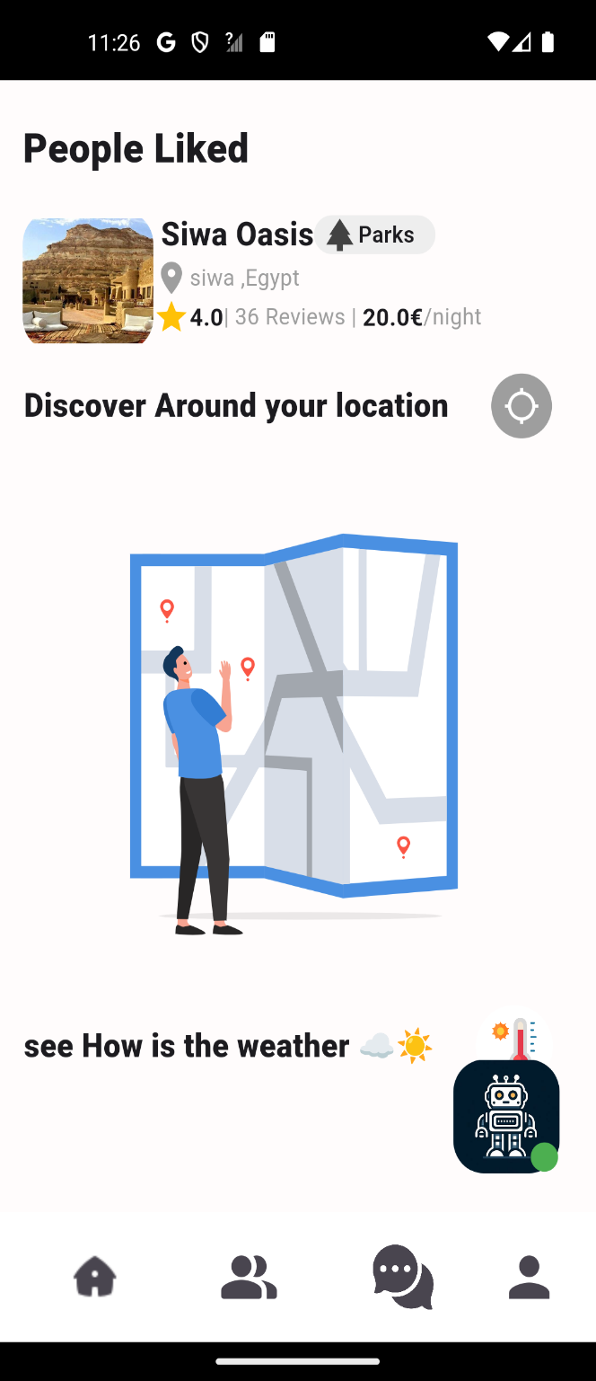

**Discover Around Your Location Section**

* An interactive feature encouraging users to explore local attractions.
* Map Illustration: A graphic showing a person interacting with a map.
* Call to Action: Text prompting users to "Discover Around your location."

**Weather Information Section**

* Provides current weather information for the user's location.
* Weather Icons: Visual representation of the weather (e.g., sun, clouds).
* Text Prompt: "See How is the weather."

Screen (5)

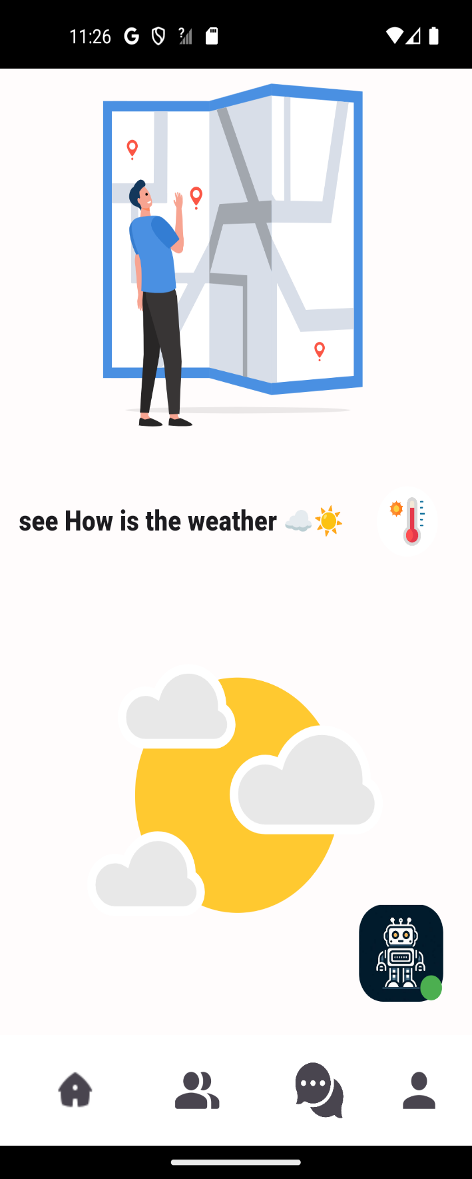

**Bottom Navigation Bar**

* **Home Icon**: Indicates the current active screen.
* **People Icon**: Likely for accessing social features or user profiles.
* **Chat Icon**: Indicates messaging or customer support functionalities.
* **Profile Icon**: Probably for accessing the user’s profile or settings.

**Design Aesthetics**

* **Color Scheme**: Utilizes a light background with dark text to ensure readability and a clean appearance.
* **Typography**: Employs modern, sans-serif fonts for clarity and professionalism.
* **Icons and Images**: Uses high-resolution icons and appealing images to enhance user engagement and provide a premium feel.

Screen (6)

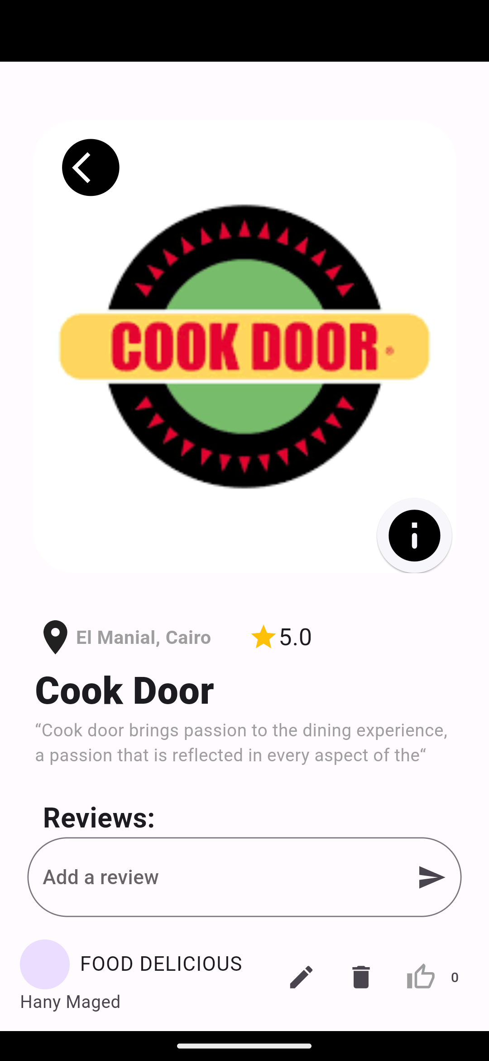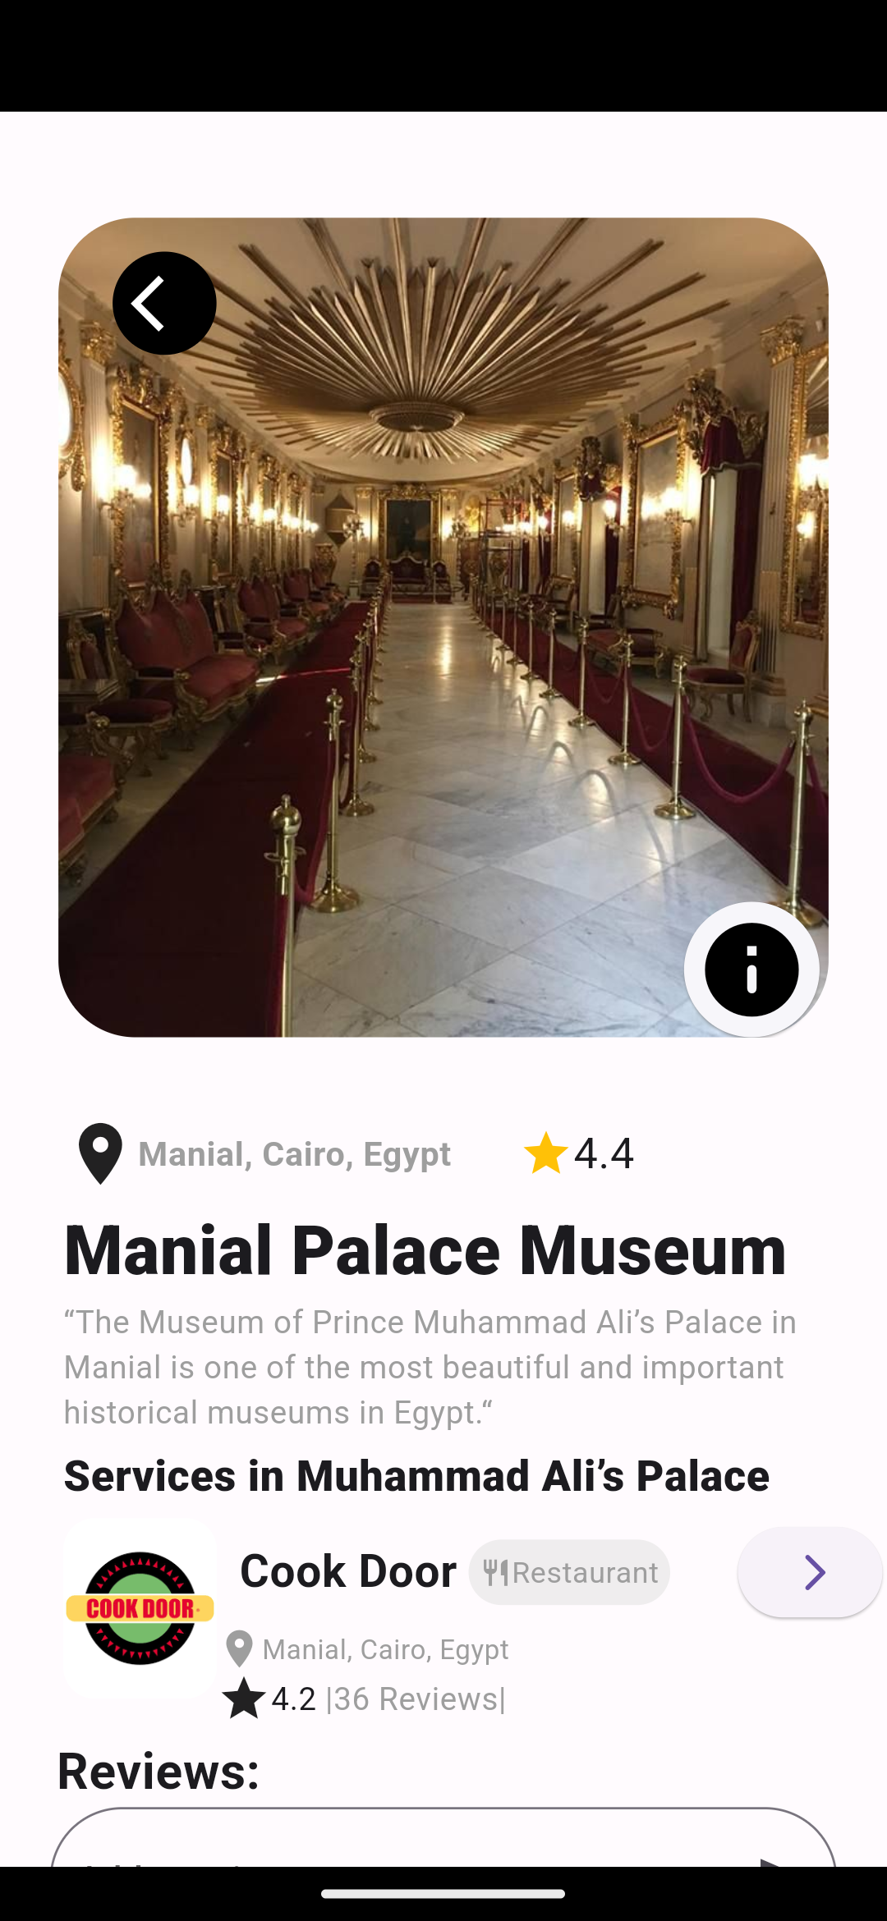

Screen (7)

Screen (8)

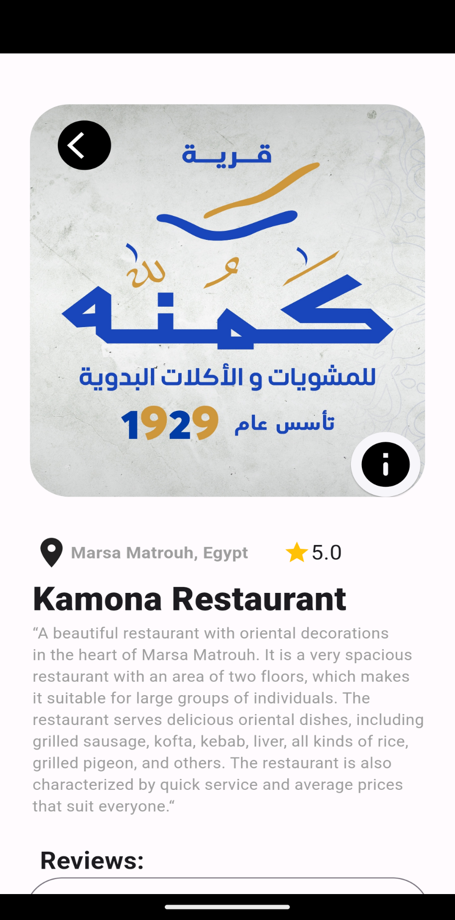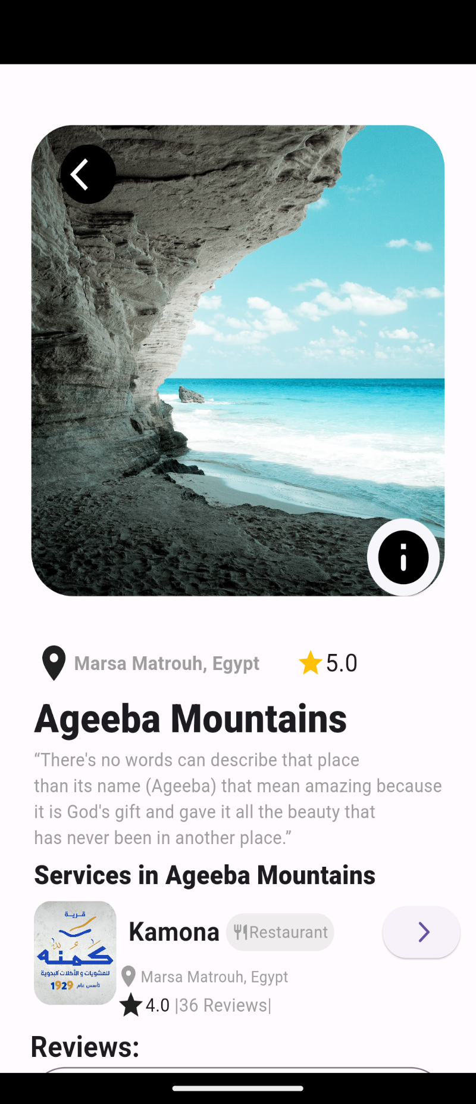

Screen (10)

Screen (9)

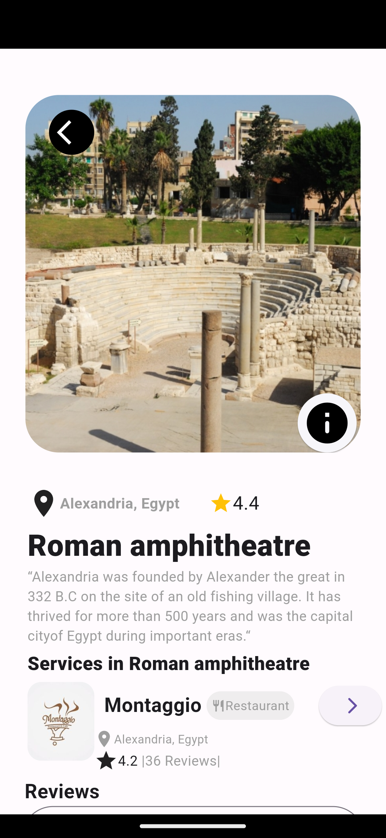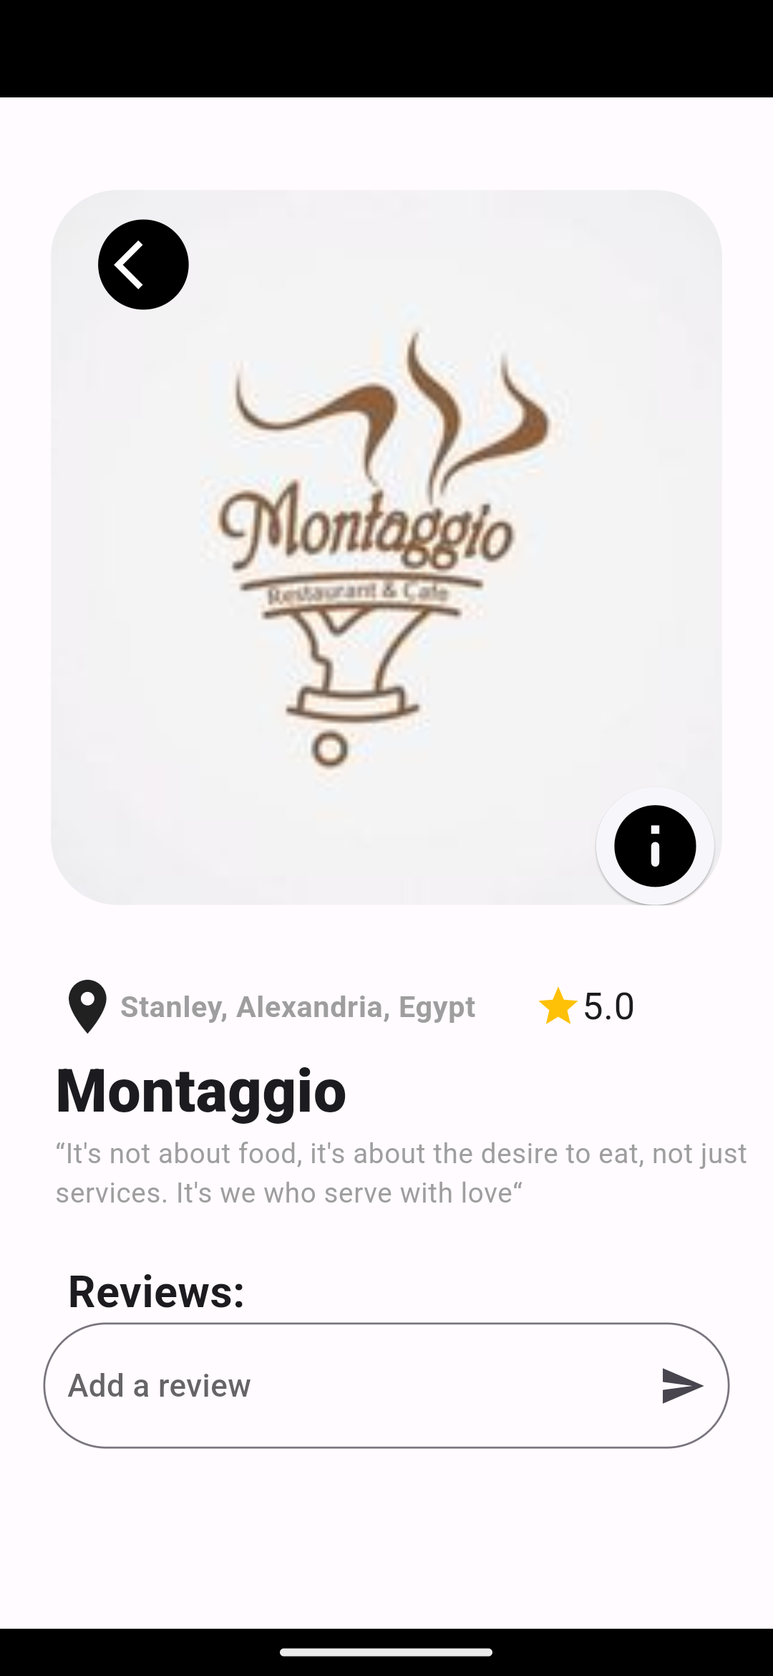

Screen (12)

Screen (11)

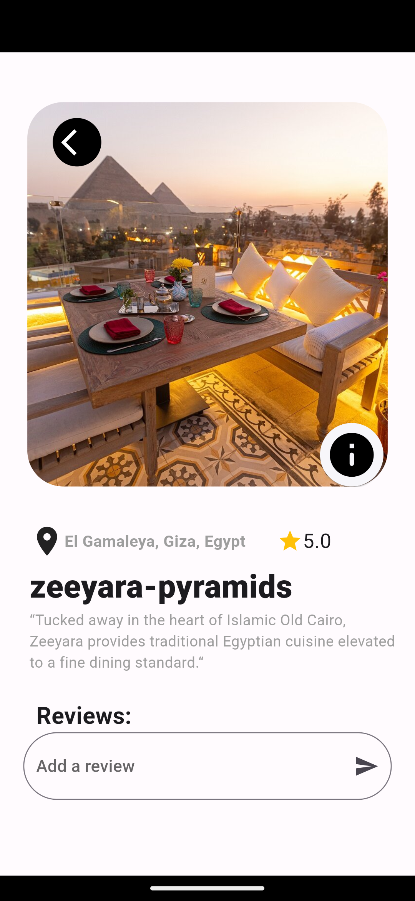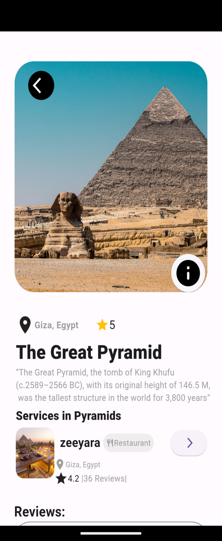

Screen (14)

Screen (13)

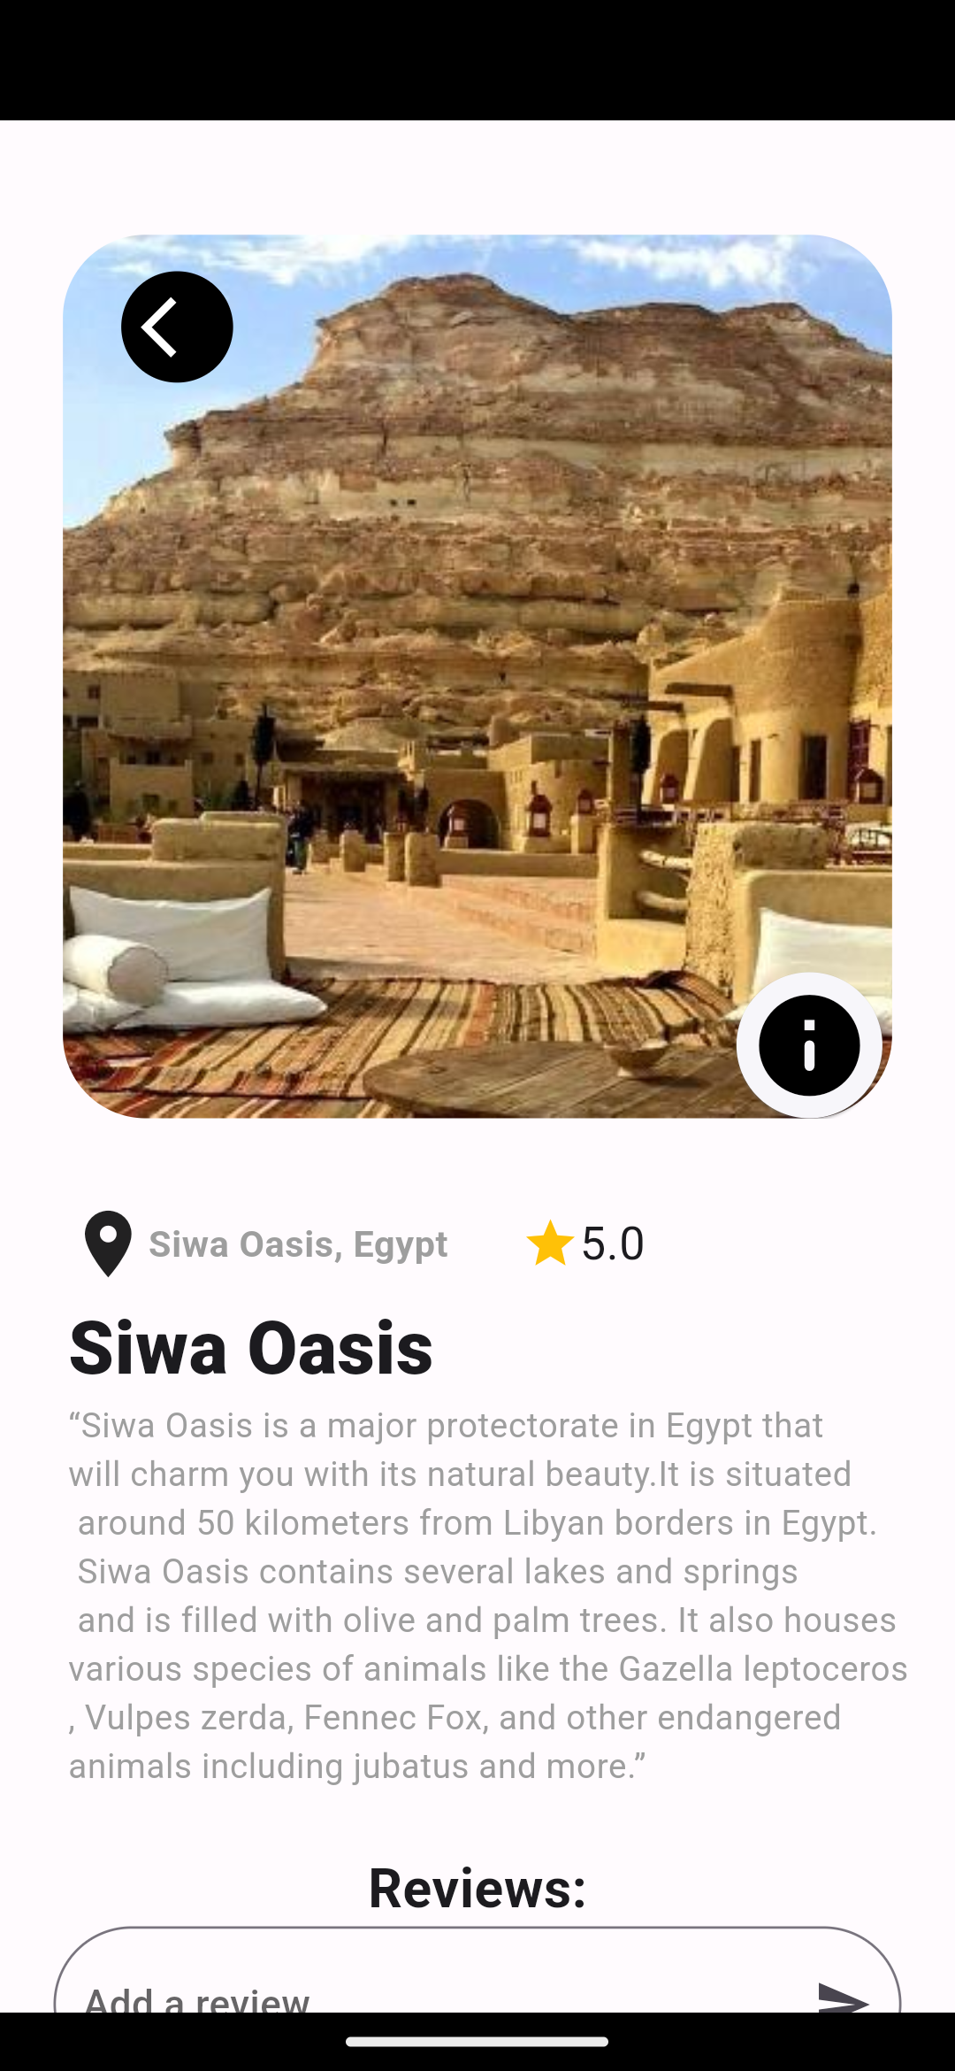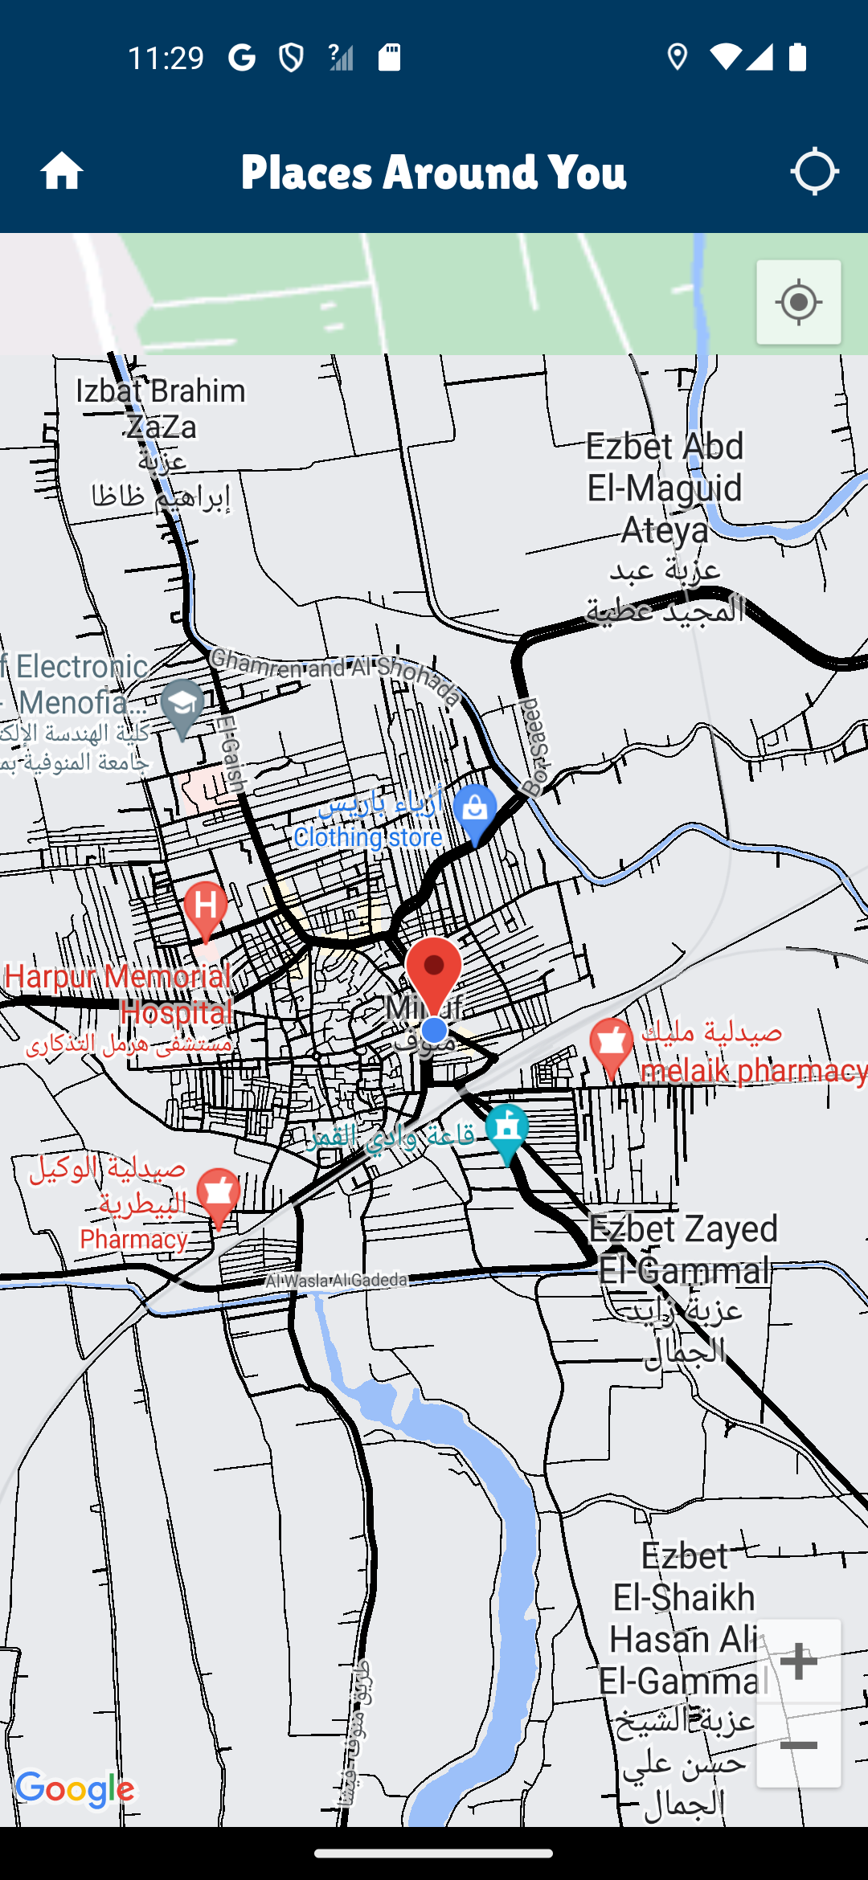

Screen (16)

Screen (15)

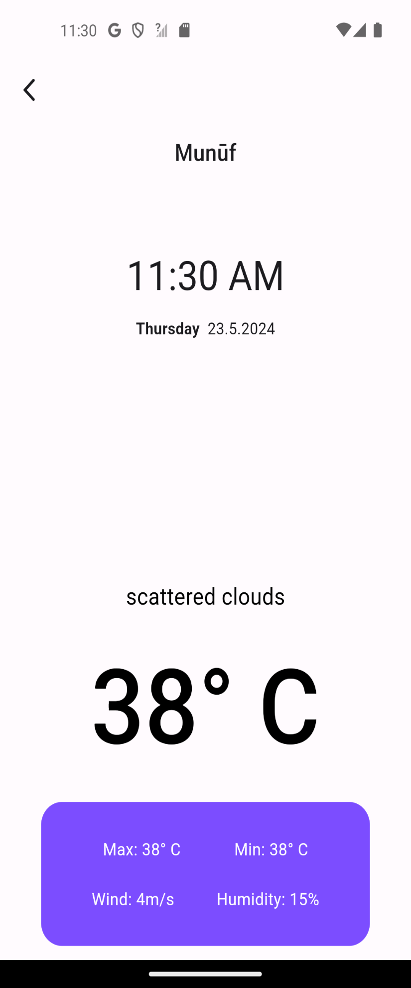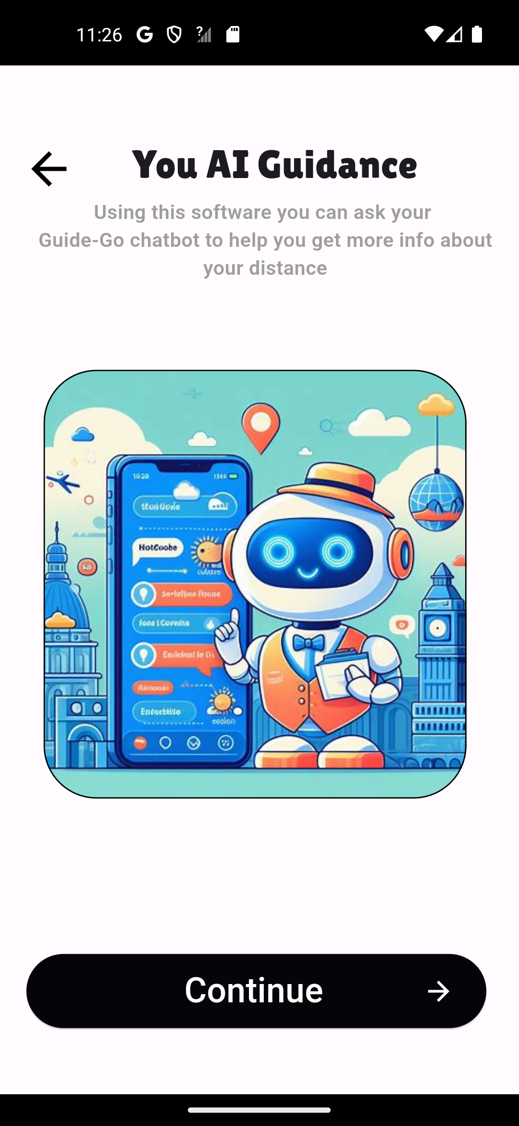

Screen (18)

Screen (17)

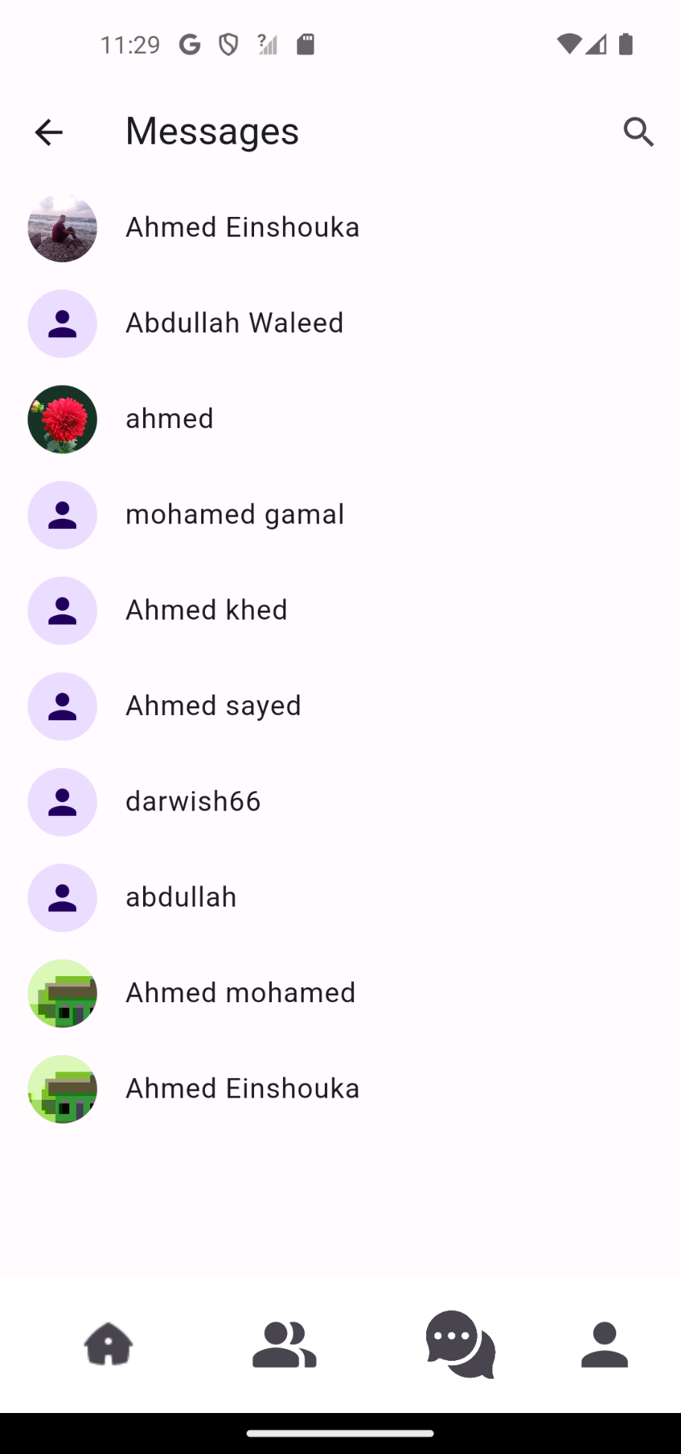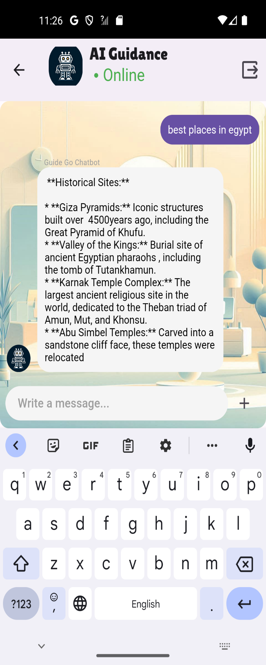

Screen (20)

Screen (19)

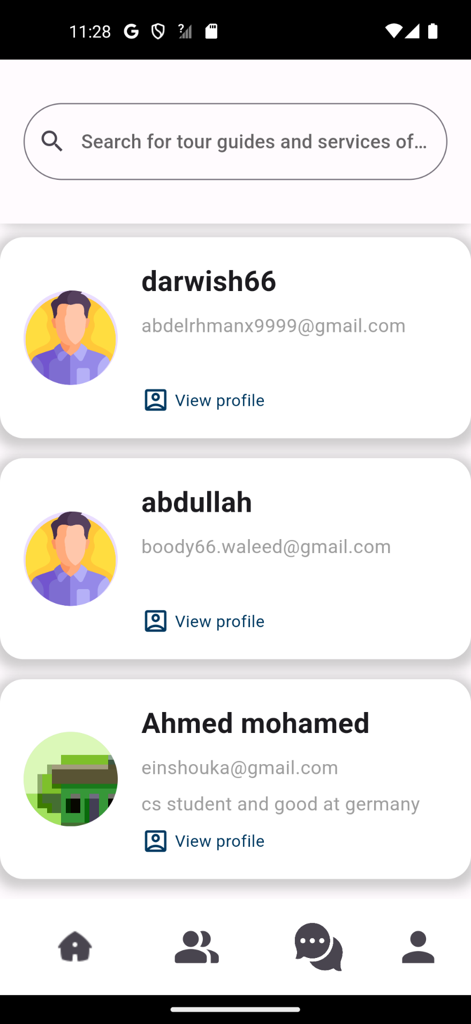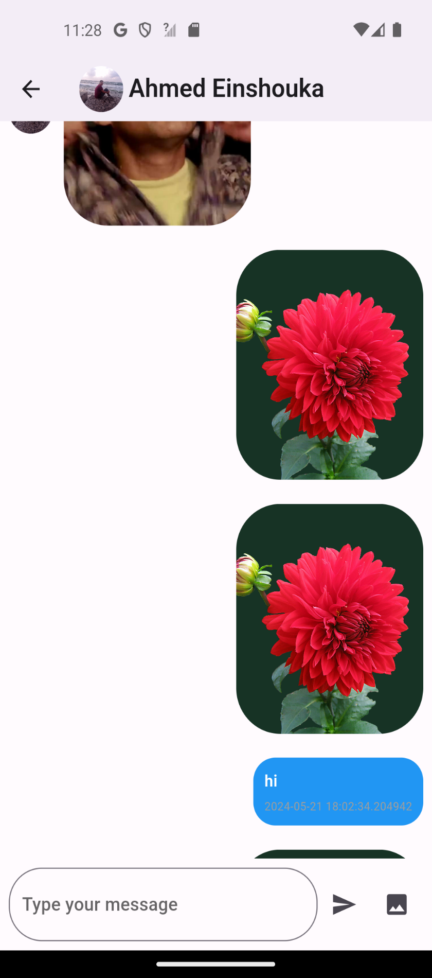

Screen (22)

Screen (21)

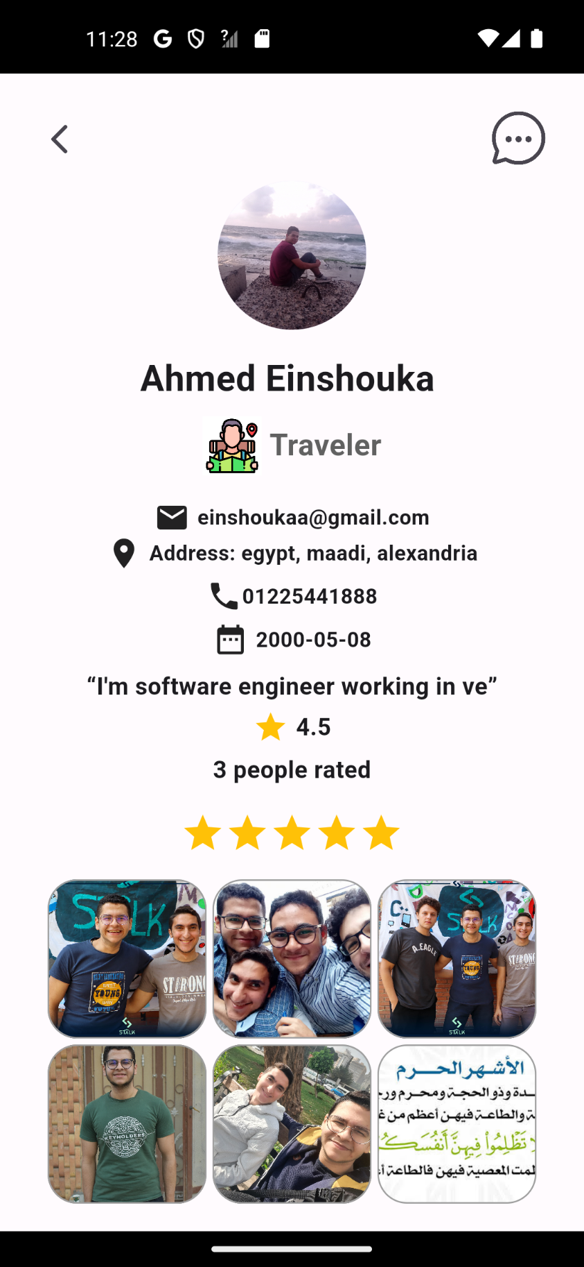

**User Profile Interface Description**

**Overview**

The user profile interface is designed to provide comprehensive information about a user within the application. The profile layout is clean, user-friendly, and features both textual and visual elements to enhance user engagement and information accessibility.

**Profile Details**

1. **Profile Picture:**
   * A circular profile picture is located at the top center of the screen. The image shows a person sitting by the sea, creating a calm and inviting atmosphere.
2. **User Information:**
   * **Name:** The user's name, "Ahmed Einshouka," is prominently displayed in bold font below the profile picture.
   * **Role:** The user is identified as a "Traveler," indicated by both text and a small icon of a person with a map.

Screen (23)

1. **Contact Information:**
   * **Email:** The user's email address is listed as einshoukaa@gmail.com.
   * **Address:** The address is specified as "Egypt, Maadi, Alexandria," providing the user's location.
   * **Phone Number:** The contact number is given
   * **Date of Birth:** The birthdate is noted as "2000-05-08."
2. **Professional Summary:**
   * A brief personal statement reads, "I'm a software engineer working in ve," indicating the user's profession and area of expertise.
3. **Ratings:**
   * **Overall Rating:** The user has an overall rating of 4.5 stars.
   * **Number of Ratings:** The rating is based on the feedback of 3 people.
   * **Visual Rating Representation:** A row of 5 stars is displayed, highlighting the user's rating visually.
4. **Gallery:**
   * **Photos:** A collection of six thumbnail images is shown below the rating section. These images depict the user with friends and colleagues, indicating social interactions and possibly professional or casual group activities.
   * **Text Image:** One of the thumbnails includes an image with Arabic text, which may be relevant to the user's background or interests.

**Design Elements**

* The design uses a simple and clear layout with ample white space, making it easy to navigate.
* Icons are used effectively to represent different types of information (e.g., email, address, phone).
* The use of a profile picture and gallery images personalizes the profile, making it more engaging.

**Purpose and Usability**

This user profile interface aims to provide a comprehensive view of the user's personal, contact, and professional information. It is designed to be user-friendly and visually appealing, enhancing the user experience within the application. The inclusion of ratings and a gallery adds depth to the profile, making it more informative and interactive.



**Chapter Five**

System Implementation

**Overview about Used Tools**

In this project, a variety of software tools were utilized to develop the system and ensure the project objectives were achieved efficiently and effectively. The tools used include:

1. **Lucid chart**: Used for creating diagrams such as context diagrams, use case diagrams, and activity diagrams.
2. **Draw.io**: Another tool for creating schematic diagrams used in system documentation.
3. **Figma**: A user interface design tool that assisted in designing the graphical interfaces of the system.
4. **Android Studio**: An integrated development environment (IDE) used for developing the Android application for the project.
5. **Visual Studio Code**: A lightweight and efficient code editor used for writing the Flutter code.
6. **Flutter**: A cross-platform development framework used to develop the application seamlessly.
7. **Firebase**: A cloud-based platform used for data management, authentication, and file storage.
8. **GitHub**: A platform for source code management and facilitating collaborative work among team members.
9. **Appium**: A tool for automated testing of mobile applications to ensure application quality.

**Overview about Programming Language Used**

The programming language and framework used for developing the application is Flutter, which employs Dart as its programming language.

Flutter: Flutter is an open-source UI software development framework created by Google. It enables developers to build natively compiled applications for mobile (iOS and Android), web, and desktop from a single codebase. Here are some key features and benefits of using Flutter:

1. Cross-Platform Development: Flutter allows for the creation of applications that run on both Android and iOS using the same codebase. This significantly reduces development time and effort as developers do not need to write separate codes for different platforms.

2. High Performance: Flutter applications are known for their high performance. This is achieved through its high-performance rendering engine, Skia, which allows for smooth animations and transitions. The framework also compiles to native ARM code for both iOS and Android, ensuring that apps run quickly and efficiently.

3. Hot Reload: One of the most praised features of Flutter is Hot Reload, which allows developers to see the changes they make to the code almost instantly without restarting the app. This feature greatly speeds up the development process and makes it easier to experiment and iterate on design.

4. Rich Widgets: Flutter is built around a highly flexible and customizable widget system. Everything in Flutter is a widget, from layout elements to text and images. This allows for the creation of complex and custom user interfaces with ease. Flutter’s widget catalog is extensive, offering a wide range of pre-designed widgets that follow the Material Design guidelines for Android and the Cupertino design for iOS.

5.Strong Community and Support: Being an open-source project backed by Google, Flutter has a large and active community. There are numerous resources, tutorials, packages, and plugins available that can help accelerate development and solve common problems.

6.Integration with Other Technologies: Flutter integrates seamlessly with other technologies and services. It supports a wide range of APIs and third-party packages that can extend its functionality, making it a versatile choice for various types of applications.

**Dart:** it is the programming language used to develop Flutter applications. Created by Google, Dart is optimized for building user interfaces, offering features that facilitate smooth and efficient development.

1.Fast and Productive: Dart is designed to be easy to learn and use, with a syntax that is clear and concise. It supports both Ahead-of-Time (AOT) and Just-in-Time (JIT) compilation, allowing for fast startup times and efficient code execution. JIT compilation, in particular, powers Flutter’s Hot Reload feature, enabling rapid development cycles.

2. Object-Oriented Language: Dart is an object-oriented language with strong typing, making it easy to structure and manage code, especially for large applications. Its class-based object-oriented approach allows developers to use familiar concepts like inheritance, mixins, and interfaces.

3.Asynchronous Programming: Dart provides robust support for asynchronous programming through its Future and Stream classes, enabling developers to write non-blocking code. This is particularly useful for handling user interactions, I/O operations, and other asynchronous tasks smoothly.

4.Comprehensive Standard Library: Dart comes with a comprehensive standard library that includes collections, math, file I/O, and more. This rich set of built-in functions and classes makes it easier to perform common programming tasks without relying heavily on third-party libraries.

5. Strong Typing with Flexibility: While Dart is strongly typed, it also offers the flexibility of type inference, which can reduce the verbosity of code while maintaining type safety. This balance helps in writing clear and maintainable code.

6.Easy Integration: Dart can easily interoperate with JavaScript, making it a good choice for both client and server-side development. This interoperability allows Dart code to be used in a variety of environments, extending its usability beyond just Flutter applications.

By leveraging Flutter and Dart, developers can build high-quality, high-performance applications efficiently and effectively. The combination of Flutter’s powerful UI capabilities and Dart’s robust programming features makes them an excellent choice for modern application development.

**Screenshot of the System**

Below are some screenshots of the system developed using the mentioned tools:

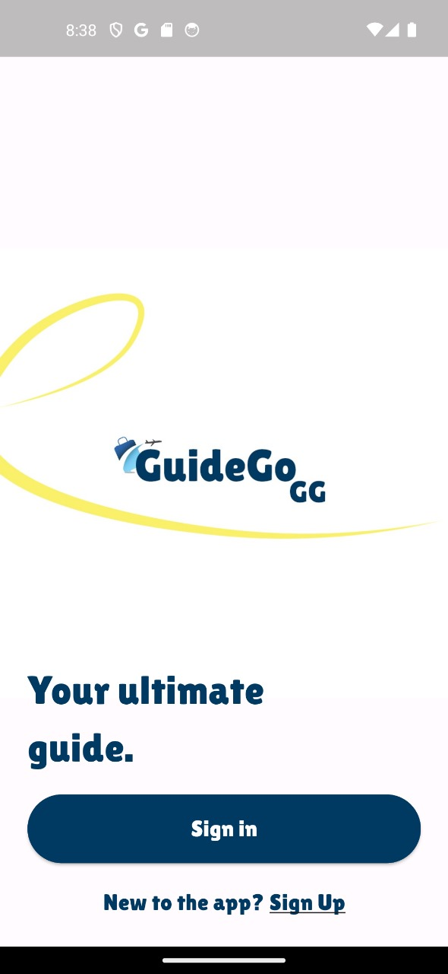 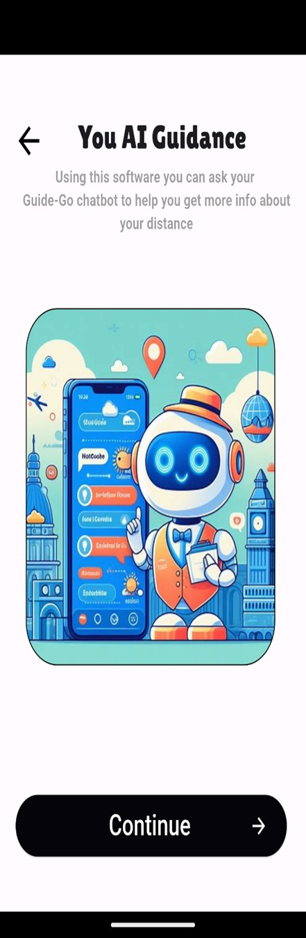

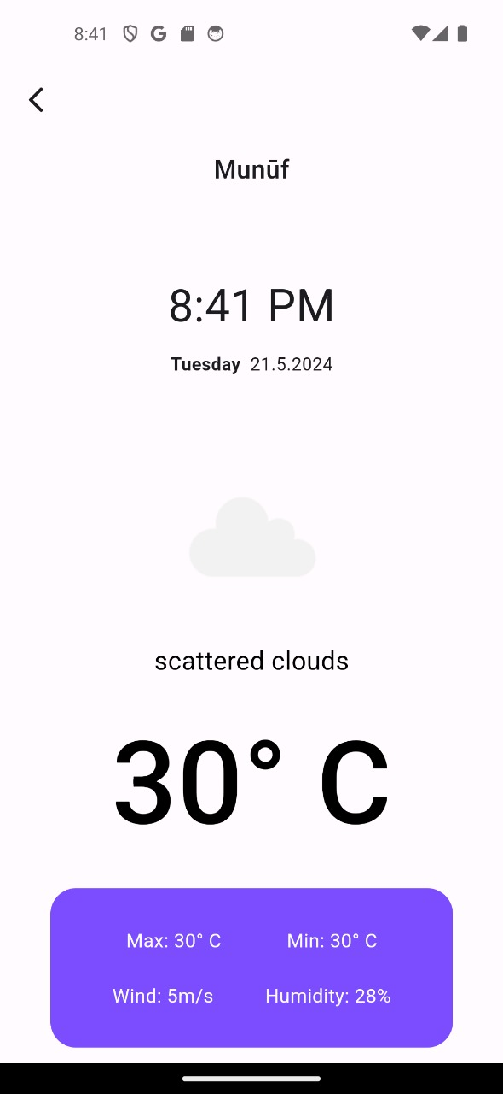 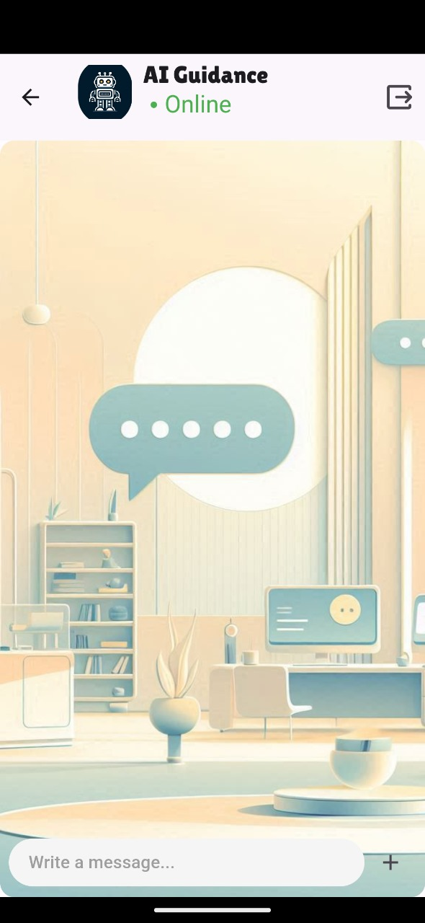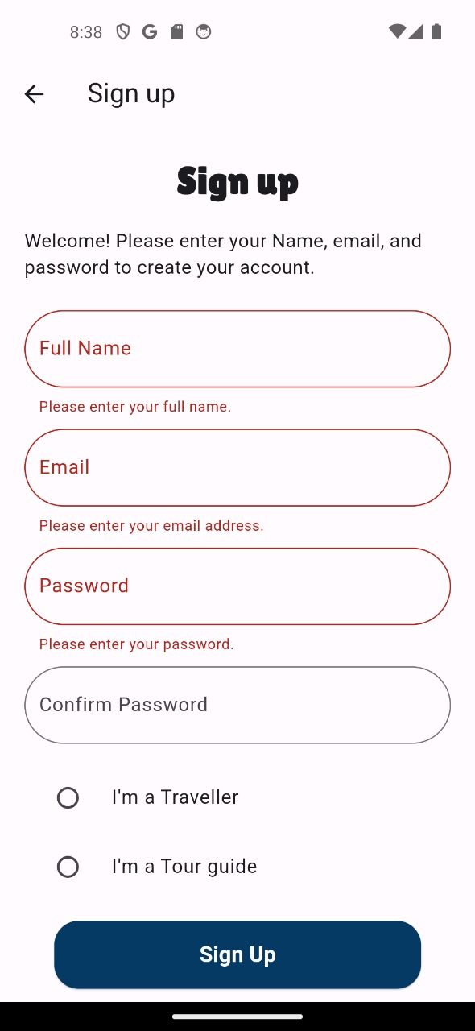 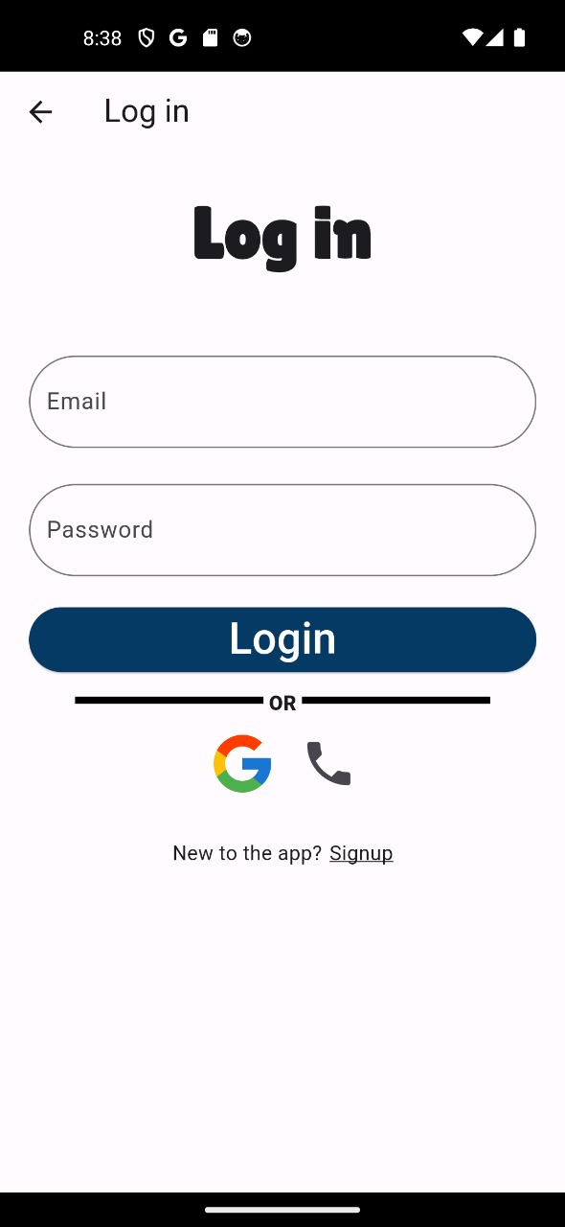



**Chapter Six**

**Testing Methodology**

**Testing Methodology**

The testing methodology adopted for this project ensures that the system functions as intended and meets the requirements specified. The methodology involves several stages of testing, each designed to identify and resolve potential issues at different levels of the system. The primary stages include:

* **Unit Testing**: Individual components or functions of the system are tested in isolation to ensure each part operates correctly.
* **Integration Testing**: Different modules or components are tested together to verify that they work as a cohesive system.
* **System Testing**: The complete system is tested as a whole to ensure that it meets the specified requirements and performs under expected conditions.
* **User Acceptance Testing (UAT**): The system is tested by the end-users to ensure that it meets their needs and is ready for deployment.

Testing tools and frameworks used include Appium for automated testing and Firebase for backend validation. Manual testing was also conducted to ensure a thorough assessment of the system's functionality.

**Login Validation**

* For the login validation, the following test cases were executed to ensure secure and correct user authentication:
* Valid Login Test: Verified that users with correct credentials can successfully log in.
* Invalid Login Test: Ensured that users with incorrect credentials receive appropriate error messages and cannot log in.
* Empty Fields Test: Checked that leaving the username or password field empty results in an error message.
* Case Sensitivity Test: Ensured that the login system correctly handles case sensitivity for usernames and passwords.
* Password Masking: The password field hides the characters entered to maintain privacy.

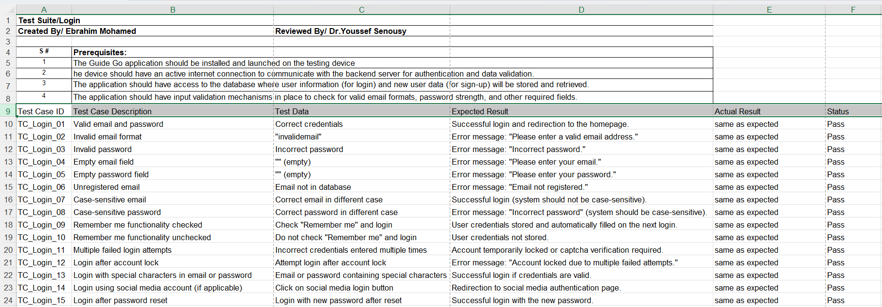

**Sign Up Validation**

Sign up validation tests ensure that new users can create accounts and that the system handles various input scenarios correctly. The following scenarios were tested:

Valid Data: Users can sign up successfully with valid information.

Invalid Email Format: The system displays an error message when an invalid email format is entered.

Password Strength: The system requires passwords to meet specified strength criteria (e.g., minimum length, special characters).

Empty Fields: The system prompts the user to fill in all required fields.

Duplicate Emails: The system prevents users from signing up with an email that is already registered.

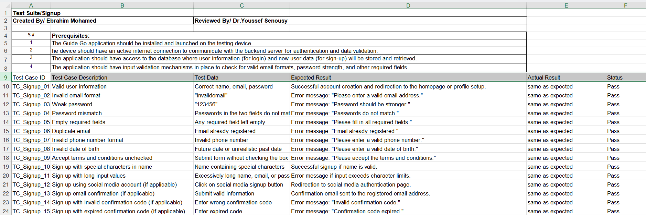

**Main Functions Validation**

The main functions validation ensures that all core functionalities of the application perform as expected. The following functionalities were tested:

**Tour Guide Booking**: Users can search for and book tour guides successfully.

**User Interface Navigation**: The application navigates smoothly between different screens and sections without errors.

**AI Chatbot Assistance**

* Response Accuracy Test: Ensured that the AI chatbot provides accurate answers to travel-related questions.
* Recommendation Test: Verified that the chatbot can suggest relevant recommendations based on user queries.
* Fallback Response Test: Checked that the chatbot provides helpful fallback responses when it doesn't understand a query.
* User Input Variability Test: Ensured that the chatbot handles different phrasings and typos correctly.

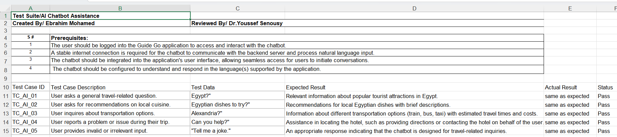

**Weather Information**

* Current Location Test: Verified that the system provides accurate weather forecasts for the user’s current location.
* Destination Forecast Test: Ensured that users can get weather information for their planned destinations.
* Data Update Test: Checked the frequency and accuracy of weather data updates.

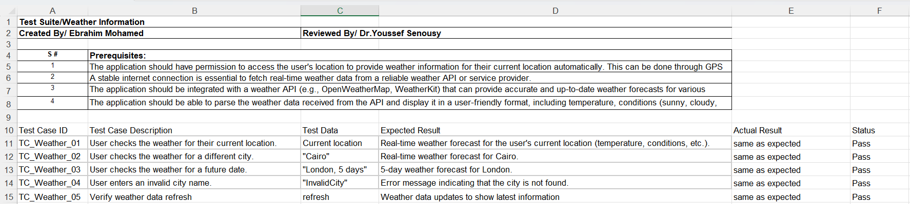

**Profile Management**

* Profile Creation Test: Verified that users can create and customize their profiles.
* Profile Update Test: Ensured that users can edit their profiles successfully.
* Profile Picture Upload Test: Checked that users can upload and change profile pictures.
* Image Uploads
* Image Format Test: Ensured the system accepts various image formats (JPEG, PNG, etc.).
* Upload Success Test: Verified that users can successfully upload images.
* Image Display Test: Ensured uploaded images display correctly in user profiles.

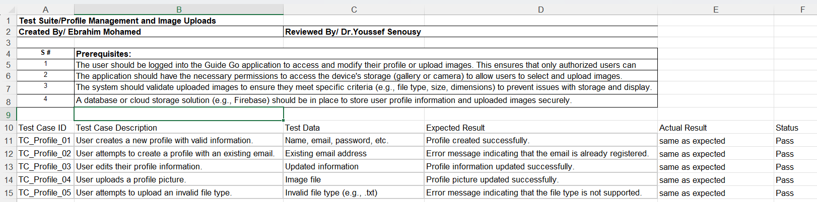

**Google Sign-In**

* Google Login Test: Verified that users can sign in using their Google accounts.
* Google Sign-Up Test: Ensured that new users can register using Google Sign-In.
* Security Test: Checked the security measures for handling Google account integration.

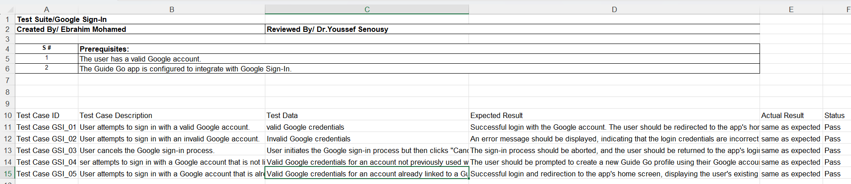

**Tour Guide Ratings and Reviews**

* Rating Submission Test: Verified that users can rate tour guides.
* Review Submission Test: Ensured that users can write and submit reviews for tour guides.
* Review Display Test: Checked that submitted reviews are correctly displayed.

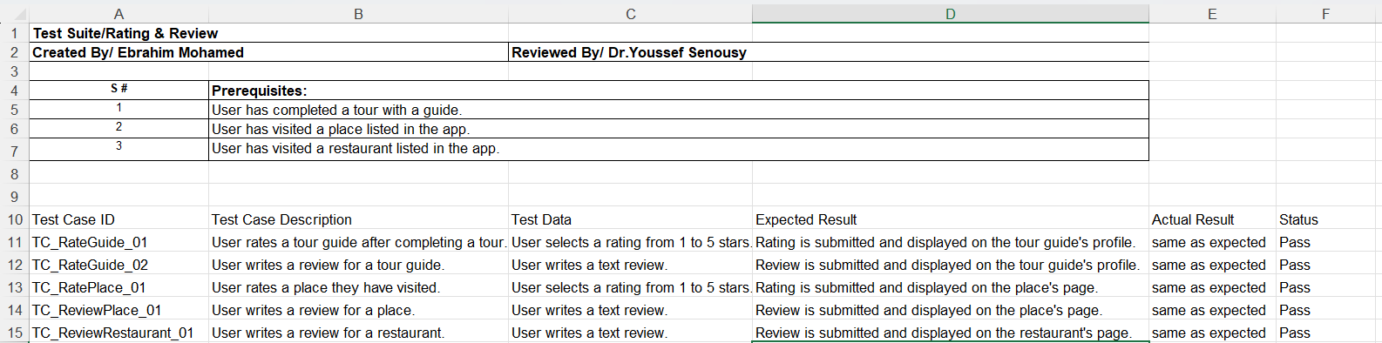

**Google Maps Integration**

* Location Service Test: Verified the integration of Google Maps for location services.
* Directions Test: Ensured users can get directions using Google Maps.
* Nearby Attractions Test: Checked that information about nearby attractions is accurate and useful.

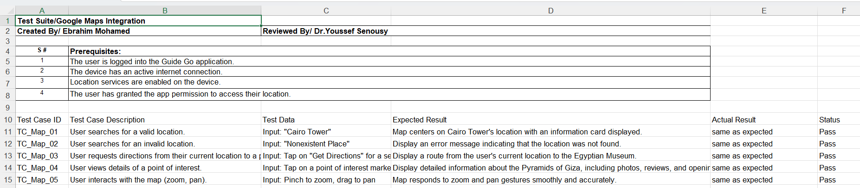

**In-App Chat (Chat App)**

* Message Sending Test: Ensured users can send messages within the app.
* Message Receiving Test: Verified that messages are received correctly.
* Chat History Test: Checked that users can view their chat history.

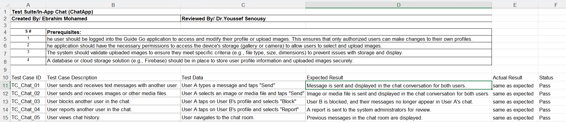



***Chapter Seven***

***Conclusion and Future Work***

**Conclusion**

This project, "Guide Go," aims to provide comprehensive travel assistance for low-budget travelers. Throughout the development process, several key aspects were emphasized:

1. **Summary of Key Arguments and Results**:
   * The project successfully integrated multiple services including tour guides, house rentals, car rentals, and camera rentals. This integration was designed to offer a holistic travel experience for users.
   * User feedback mechanisms and real-time updates were incorporated to enhance the overall user experience.
2. **Implications of the Research**:
   * By providing a one-stop solution for low-budget travelers, the project aims to democratize travel, making it more accessible and enjoyable.
   * The project's model leverages the sharing economy, which supports local communities and promotes sustainable tourism.
3. **Research Process Reflection**:
   * The project began with identifying the core challenges faced by low-budget travelers, followed by designing a solution that addresses these issues comprehensively.
   * Various technologies and tools such as Android Studio, Flutter, and Firebase were utilized to develop and implement the system.
4. **New Knowledge Contribution**:
   * The project introduced a unified platform that connects various travel-related services, which was previously unavailable in a single application.
   * Innovations in user authentication and booking management were also implemented to enhance security and user satisfaction.
5. **Significance of the project**

is that it addresses a common problem faced by many travelers who want to explore new places on a low budget. The project offers a unique solution that combines various aspects of travel assistance into one platform that can cater to the diverse needs and preferences of low-budget travelers. The project has the potential to benefit both the users and the service providers by creating a mutually beneficial relationship. The users can enjoy their trips without worrying about the quality or convenience of their travel arrangements, while the service providers can earn income and exposure by offering their services to a large and growing market. The project also contributes to the promotion of cultural exchange and tourism development by facilitating the interaction between travelers and locals and encouraging the exploration of different destinations. The project is significant because it aims to make travel experiences more enjoyable, affordable, and accessible for all.

**Future Work**

Looking ahead, several enhancements and new features can be considered to further improve the "Guide Go" project:

User and Guide Profile Management:

Introduce property listing features for house, car, and camera owners to manage their offerings more effectively.

Add the capability for service providers to create profiles, manage listings, and interact with travelers and guides.

**Booking Management:**

Enhance booking management by integrating more sophisticated scheduling and availability tracking systems.

Implement secure payment processing with more options for fund withdrawal and booking cancellation policies.

Add a commission feature to facilitate transactions between travelers, tour guides, and service providers, ensuring a secure and transparent payment process.

**User Authentication and Security:**

Strengthen user authentication mechanisms to ensure robust security.

Incorporate user verification processes and customizable privacy settings.

**Additional Features:**

Introduce a document scanner feature to streamline the booking and verification process.

Add system notifications to keep users informed about their bookings and any changes.

Develop data analytics tools to provide insights into user behavior and preferences, which can guide future improvements.

Implement data backup and recovery measures to protect user information.

Expand the interface to support multiple languages, catering to a broader audience.

**Service Provider Role:**

Add a third type of user, the service provider, who can offer services such as car rentals, camera rentals, and house rentals.

Enable service providers to list their services, manage bookings, and interact with travelers and tour guides.

Develop features to manage transactions and communications between service providers and users, ensuring a seamless experience.

These enhancements will further improve the functionality, security, and user experience of the "Guide Go" project, making it a more comprehensive and versatile platform for all users involved.

**REFERENCES**

1- Skyscanner, <https://www.skyscanner.com/>

2- Hostelworld, <https://www.hostelworld.com/>

3- Uber, <https://www.uber.com/>

4- Groupon, <https://www.groupon.com/>

5- Couchsurfing, <https://www.couchsurfing.com/>

6- TripAdvisor, <https://www.tripadvisor.com/>

7- Lonely Planet, <https://www.lonelyplanet.com/>

8- Meetup, <https://www.meetup.com/>

9- Nomadic Matt’s Superstar Blogging, <https://www.nomadicmatt.com/>

10- Travel Hacking 101, <https://travelhacking.org/>

11- The Ultimate Travel Writer’s Program, <https://travelwriting2.com/>

12- Trail Wallet, <https://voyagetravelapps.com/trail-wallet/>

13- TripIt, <https://www.tripit.com/web>

14- Google Translate, <https://translate.google.com/>

15- NARMELAN THARMALINGAM,2022, <https://www.kaggle.com/datasets/narmelan/travelleisure-worlds-best-hotels-2022>

16- Mustafa-taha,2023,< <https://www.kaggle.com/datasets/mu6tf2/egypt-housing-rent>>

1. Guide Go Team octoper,2023,<<https://docs.google.com/spreadsheets/d/1miUM1qQuOA3b39ys61HhTOQY-s0RYjlVMQocqL66eMc/edit?usp=sharing>>
2. Guide Go Team octoper,2023,<<https://docs.google.com/spreadsheets/d/1miUM1qQuOA3b39ys61HhTOQY-s0RYjlVMQocqL66eMc/edit?usp=sharing>>
3. Guide Go Team octoper,2023,<<https://docs.google.com/spreadsheets/d/1miUM1qQuOA3b39ys61HhTOQY-s0RYjlVMQocqL66eMc/edit?usp=sharing>>
4. NARMELAN THARMALINGAM,2022, <https://www.kaggle.com/datasets/narmelan/travelleisure-worlds-best-hotels-2022>
5. Mustafa-taha,2023,< <https://www.kaggle.com/datasets/mu6tf2/egypt-housing-rent>>